China’s Epic Journey from Poverty to Prosperity

The State Council Information Office of
the People’s Republic of China
September 2021

Contents

Preface 1
I. A Critical Step Towards National Rejuvenation 4
II. Prosperity Through All-Round Development 10
1. Sustained and Healthy Economic Growth 10
2. Expanding People’s Democracy 17
3. Flourishing Cultural Sector 22
4. Improving People’s Wellbeing 26
5. Historic Changes to the Eco-Environment 36
III. Prosperity for All 42
1. Prosperity for Every Individual 42
2. Integrated Urban-Rural Development 46
3. Coordinated Development Across Regions 52
IV. Prosperity Through Hard Work 56
1. Always Putting the People First 56
2. Developing Sound Policies and Strategies 58
3. Development Through Reform and Opening Up 62
4. Perseverance over Generations 64
V. The World Benefits from China’s Prosperity 67
Conclusion 71

Preface
Achieving moderate prosperity fulfills a long-cherished dream of the Chinese nation.
On July 1, 2021, at the ceremony marking the centenary of the Communist Party of China (CPC), Xi Jinping, general secretary of the CPC Central Committee and president of China, declared that thanks to the continued efforts of the whole Party and the entire nation, China had realized the First Centenary Goal of building a moderately prosperous society in all respects. This means that it has put an end to absolute poverty, and is now marching in confident strides towards the Second Centenary Goal of building a great modern socialist country.
Over the past hundred years, led by the CPC, generations of the Chinese people have persevered, progressing step by step from a subsistence standard of living to piecemeal prosperity, then to moderate prosperity throughout the country.
The realization of moderate prosperity is a glorious achievement for the Chinese nation. Once subjected to oppression and humiliation, China now stands firm among the nations of the world. This represents one significant step closer to the Chinese Dream of national rejuvenation, and testifies to China’s historic transformation – from standing upright to becoming prosperous and growing in strength. This achievement reflects the Chinese people’s aspiration for a better life, and their indomitable will to surmount all difficulties and challenges on their way forward. It has boosted their pride and confidence in the nation, and inspired further endeavors on the quest for national rejuvenation.
The realization of moderate prosperity is a remarkable achievement by the Chinese people. From difficult beginnings they have made both material and cultural progress, moving forward with full confidence along the path of socialism with Chinese characteristics. The creation of a moderately prosperous society epitomizes their ingenuity, diligence, commitment to progress, and determination to pursue their dream and effect change for the better. Their living standards have improved markedly, and they have stronger faith in the path, theory, system and culture of Chinese socialism. The Chinese people are industrious, courageous and honorable – a great and heroic people.
The realization of moderate prosperity is a commendable achievement for the CPC. Over the past hundred years, the CPC has grown from a small party with just over 50 members into the largest and most influential governing party in the world, with more than 95 million members in a country of over 1.4 billion people. Throughout this process, it has always been at the forefront of the times. In bringing about moderate prosperity, it has fulfilled a solemn promise, and lived up to its original aspiration and founding mission to seek happiness for the people and rejuvenate the Chinese nation. Leading the people in overcoming obstacles and moving forward, the CPC has won their trust and support with real actions.
The realization of moderate prosperity is a major contribution China has made to the world. Over the past hundred years, China has emerged from poverty and the scourge of war, and become a dynamic and prosperous country, standing tall and proud in the East. In achieving moderate prosperity for the Chinese people, China has contributed to its own development and delivered benefits to the rest of the world. This has created positive momentum for world peace and common development, and contributed China’s strength to building a global community of shared future and a better world.
China is a populous country with complex national conditions, which in the recent past was afflicted with weak economic foundations. To realize moderate prosperity has required great perseverance, and represents a notable achievement on the part of the CPC and the people. But there is still much to do to improve living standards – the challenge remains between unbalanced and inadequate development and the people’s growing expectation for a better life. The CPC will lead the people to work harder for well-rounded human development and common prosperity.
To document China’s journey to moderate prosperity and to share its unique experience in modernization with the rest of the world, the Chinese government is releasing this white paper.

I. A Critical Step Towards National
Rejuvenation
Xiaokang, meaning moderate prosperity, has been a consistent aspiration of the Chinese nation since ancient times. More than 2,000 years ago the term appeared in the Book of Songs to mean modest comfort:

The people are hard-pressed, they need some modest comfort.
Do well by the Central Plains, and your rule will spread beyond.

Centuries later the Book of Rites described the ideal state of society that xiaokang would bring about. Both gave expression to the ancient Chinese people’s desire for a better life. But for millennia moderate prosperity remained a dream. After the Opium War (1840-1842), China was gradually reduced to a semi-colonial, semi-feudal society and was subjected to terrible oppression. It went through immense humiliation, its people endured untold suffering, and the ancient Chinese civilization lost its way. However, the indomitable Chinese people never lost heart – they continued to fight tenaciously for their dream of a happy life.
The founding of the CPC a hundred years ago was a pivotal event in Chinese history. From the outset, the CPC has made the wellbeing of the Chinese people and the rejuvenation of the Chinese nation its abiding goals. Committed to meeting the people’s expectation for a better life, China’s communist movement, with Mao Zedong, Deng Xiaoping, Jiang Zemin, Hu Jintao and Xi Jinping as its leading representatives, has united the Chinese people in a tireless struggle over generations, pressing ahead towards the goal of building a moderately prosperous society in all respects.
Led by the CPC, the Chinese people have achieved one success after another. They won victory in the New Democratic Revolution, and founded the People’s Republic of China (PRC) in 1949. The socialist revolution, the establishment of socialism as China’s basic system, and the ensuing socialist construction brought about the most extensive and profound social changes in the history of the nation.
The transformation from a huge, poor and backward country in the East into a thriving socialist China created the fundamental political conditions and the institutional and material foundations for building a moderately prosperous society. It also provided an unfailing source of inspiration and secured the means required to complete this mission.
After the launch of reform and opening up in 1978, the CPC made continuous efforts to build a better-off society, raising the living standards in China from bare subsistence to a basic level of moderate prosperity, and then ultimately to moderate prosperity in all respects.
In the early years of reform and opening up, Deng Xiaoping for the first time used the term xiaokang to present his vision of China’s modernization. He set the goal of delivering a xiaokang life for the Chinese people and building a xiaokang society by the end of the 20th century. “By xiaokang, we mean a per capita GNP of US$800,” he specified.
This long-cherished dream, grounded in traditional Chinese culture and bearing the distinctive hallmarks of the nation, has since become a significant milestone on China’s journey towards modernization.
At its 12th National Congress in 1982, the CPC for the first time made achieving xiaokang the overall objective of China’s economic development, and set the goal of delivering a life of moderate cultural and material prosperity for the people by the end of the 20th century.
At its 13th National Congress in 1987, the CPC formulated a three-step strategic plan for China’s modernization, and set the goal for the second step as elevating the people’s living standards to the level of moderate prosperity by the end of the 20th century.
At its 14th National Congress in 1992, when the basic needs of the Chinese people had largely been met, the CPC envisioned that their living standards would further rise, from simply having the basic necessities to enjoying moderate prosperity by the end of the 20th century.
At its 15th National Congress in 1997, the CPC put forward a new three-step strategic plan for economic development, setting the goal of creating a better-off life for the people by 2010.
Through perseverance and effort over these years, China achieved basic moderate prosperity at the end of the 20th century as scheduled.
At its 16th National Congress in 2002, the CPC pointed out that moderate prosperity remained at a relatively low level – it was not all-inclusive and was very unbalanced. Thus the Party set the objective of building a moderately prosperous society in all respects. For this purpose, in the first two decades of the 21st century China would further develop the economy, improve democracy, advance science and education, enrich culture, foster social harmony, and upgrade the quality of life.
At its 17th National Congress in 2007, the CPC drew up a comprehensive plan for complete success in building a moderately prosperous society in all respects, and fleshed out the detail, setting new requirements for economic, political, cultural, social and eco-environmental progress.
After China entered the new era, the drive to achieve moderate prosperity in all respects reached a critical point. Firmly focusing on the goal, the CPC Central Committee with Xi Jinping at its core defined the Five-sphere Integrated Plan and the Four-pronged Comprehensive Strategy, designed to overcome all remaining obstacles.
At its 18th National Congress in 2012, the CPC announced that China would realize the First Centenary Goal of building a moderately prosperous society in all respects by 2021 when the Party would celebrate its centenary. It defined the metrics for such a society – sustained and sound economic development, greater people’s democracy, a significant improvement in cultural soft power, higher living standards, and major progress in building a resource-conserving and environment-friendly society.
At its 19th National Congress in 2017, the CPC demonstrated its understanding that China had reached a historic juncture and development stage. It conducted a comprehensive analysis of the fundamental conditions required to achieve all-round moderate prosperity, and the internal and external factors impacting on the process. On this basis it defined a strategy for securing success in building a moderately prosperous society in all respects and embarking on a journey to fully build a modern socialist China.
President Xi gave high priority to this endeavor in governance, presenting a series of important ideas and concepts and making a number of major decisions and arrangements. He emphasized the following issues:
• To achieve moderate prosperity in all respects is a solemn promise made by the CPC. It is also a critical step towards realizing the Chinese Dream of national rejuvenation.
• In the Four-pronged Comprehensive Strategy, achieving the First Centenary Goal is the overarching and strategic objective, while deeper reform, advancing the rule of law, and strengthening Party self-governance are strategic measures.
• Moderate prosperity in all respects means coordinated economic, political, cultural, social and eco-environmental progress, to the benefit of the entire population and covering both urban and rural areas.
• Raising the standard of living of rural residents is critical to China’s success in realizing moderate prosperity, as the most challenging and onerous tasks lie in rural areas, especially the impoverished areas.
• China must repair without delay the weak links that impede its endeavors to complete the First Centenary Goal.
• Only through good solid work can China accomplish moderate prosperity in all respects, achieve basic modernization, and realize national rejuvenation.
President Xi has assumed leadership, made plans, and put his weight behind the endeavor to build a moderately prosperous society in all respects. He has rallied around him Party members and the Chinese people, and led them in eliminating absolute poverty, advancing reform, combating Covid-19, controlling pollution, and defusing risks. Under his leadership, the Chinese people have gained a stronger sense of fulfillment, happiness and security. China has addressed many long-standing and complex problems, and achieved many objectives where progress had been slow. The Party and the country have achieved historic successes and transformations in the pursuit of their cause.
After unremitting hard work by the entire Party and all the people, the moderately prosperous society in all respects has come to fruition as scheduled. This marks a critical step towards national rejuvenation.
At the ceremony marking the centenary of the CPC on July 1, 2021, General Secretary Xi declared that China had succeeded in the First Centenary Goal of building a moderately prosperous society in all respects through the continued efforts of the whole Party and the entire nation.

II. Prosperity Through
All-Round Development
All-round development is essential to moderate prosperity. In pursuing moderate prosperity, China emphasizes balanced, coordinated and sustainable progress in the economic, political, cultural, social, and eco-environmental fields. It aims to meet people’s growing needs in all areas and at all levels and to promote their well-rounded development. Moderate prosperity makes China a strong and prosperous country striving for national rejuvenation and people’s wellbeing.
1. Sustained and Healthy Economic Growth
A sound economy underpins moderate prosperity in all respects. The CPC considers national development to be its top priority in governance and the key to tackling all the challenges facing China. Under its leadership, the Chinese people have focused on economic development and expanded the productive forces, and have made every effort to steer China’s development towards higher quality and efficiency, as well as greater equity, sustainability and security. China’s economic power, scientific and technological capabilities, and its composite national strength have significantly increased.
Economic strength has increased significantly. China’s GDP soared from RMB67.9 billion in 1952 to RMB101.6 trillion in 2020. As the world’s second largest economy, it accounts for over 17 percent of the global total (Chart 1). With per capita GDP rising from less than US$100 in 1952 to over US$10,000 in 2020, China has achieved a historic transformation from a low-income country to an upper-middle-income country (Chart 2). For years it has ranked first in the world in terms of added value in the manufacturing sector and output of over 220 major industrial products. It has also been the world’s largest manufacturing country for the past 11 years.
China ranks first in terms of trade in goods and foreign exchange reserves, and ranks second in terms of its trade in services and consumer market. In 2020, it was the largest recipient of foreign direct investment. The vitality, potential and staying power of its economy have been nurtured by a population of over 1.4 billion in pursuit of common prosperity, including a middle-income group of over 400 million people that keeps expanding – offering a supersized market growing faster than any other place in the world.
In 2020, China was the first country to bring Covid-19 under control and reopen its economy. It was also the first economy to shift back from negative to positive growth. This reflects the resilience of China’s economy.

Chart 1 China’s GDP (1952-2020)
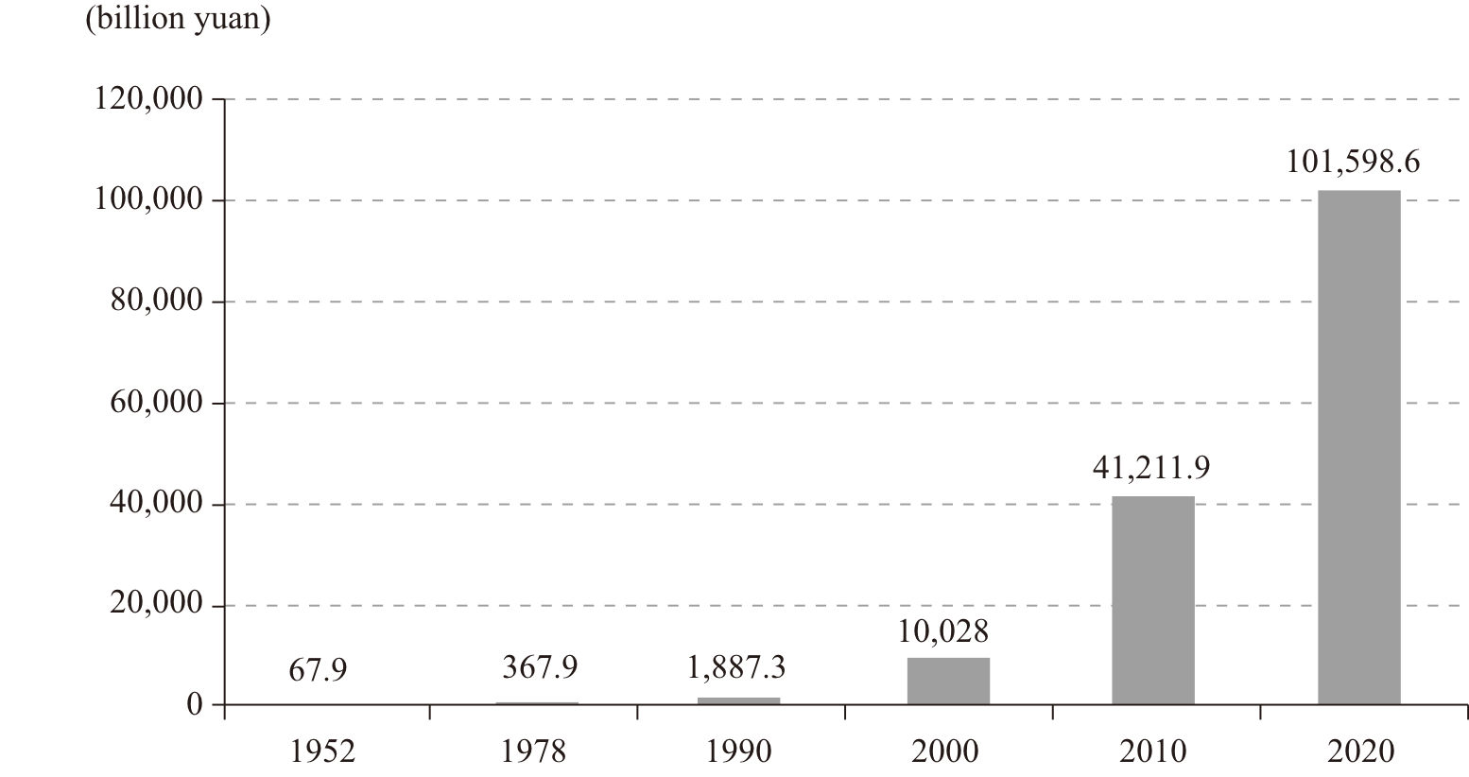

Chart 2 China’s per capita GDP (1952-2020)
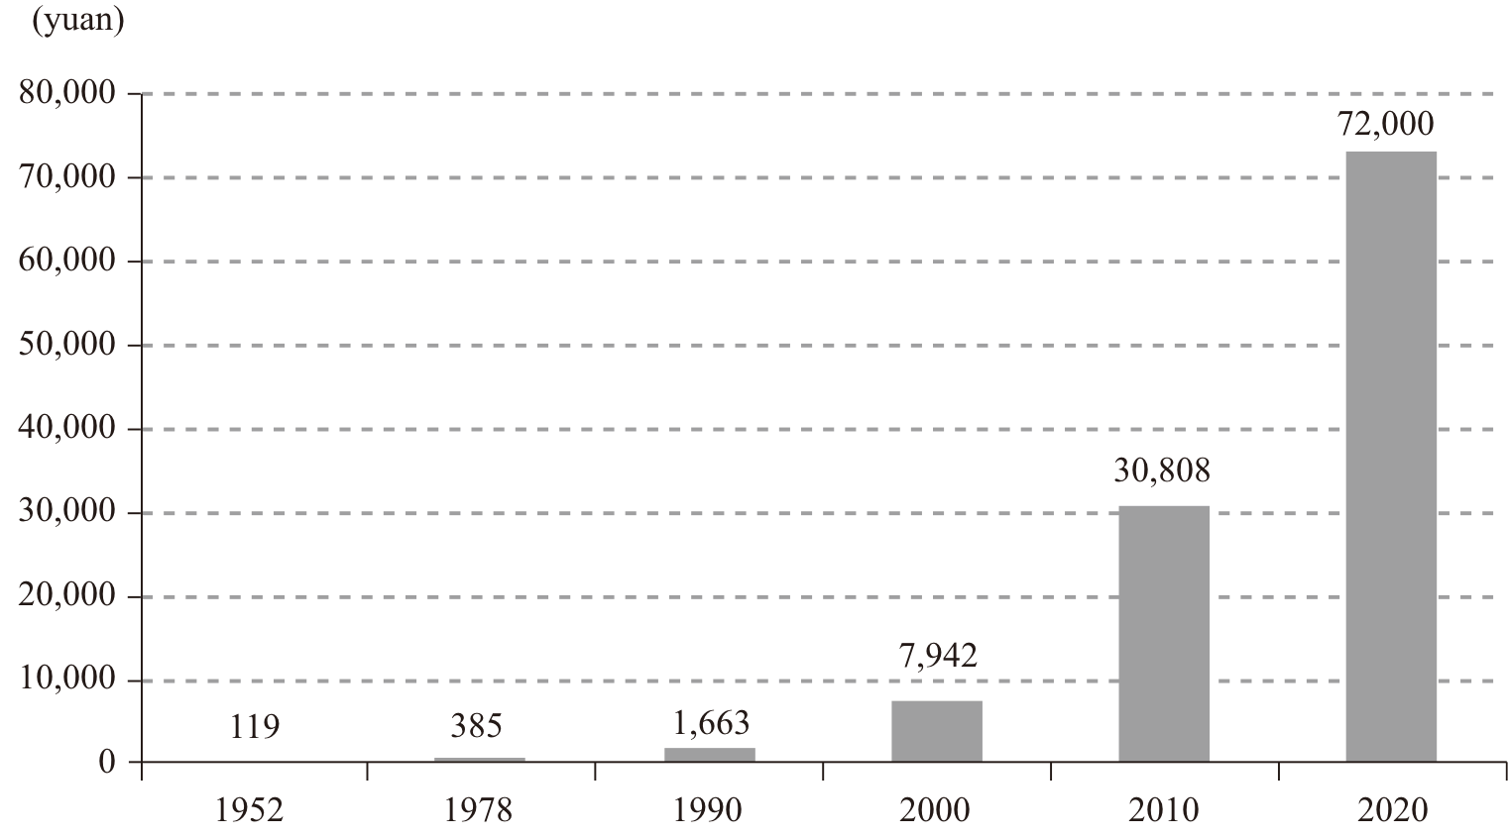

Exponential advances have been made in science and technology. The dream of moderate prosperity has been realized with the support of science and technology.
In the early years of the PRC, even matches and nails had to be imported. Now great successes have been achieved in quantum information, iron-based superconductors, neutrinos, stem cells, brain science and other frontier fields. Major breakthroughs have been made in a large number of strategic high technologies, including manned space flight and lunar exploration, the BeiDou Navigation Satellite System, manned deep-sea submersibles, high-speed railways, 5G mobile communications, and supercomputing. China is now a leader in innovation, building greater strengths in science and technology (Panel 1).

Panel 1 Technological Advances and Strategic Innovations

More R&D spending
In 2020, China spent RMB2.4 trillion on R&D, ranking second in the world. Its R&D intensity (ratio of R&D to GDP) reached 2.4 percent. A total of 1,345,000 utility patent applications were filed with domestic agencies and 441,000 were granted. In addition, 69,000 international patent applications were submitted through the Patent Cooperation Treaty. China ranked 14th on the Global Innovation Index in 2020 and was the only middle-income economy in the top 30 on this list.
More innovation centers
By the end of 2020, China had established 533 key national labs, 350 national engineering research centers (also known as national engineering labs), 1,636 national enterprise technology centers, 212 mass entrepreneurship and innovation bases, 1,287 national technology enterprise incubators, and 2,251 makerspaces approved by the Ministry of Science and Technology.
The central government is supporting efforts to build Beijing, Shanghai and the Guangdong-Hong Kong-Macao Greater Bay Area into international centers for science and technology innovation, and is developing comprehensive national science centers in Huairou of Beijing, Zhangjiang of Shanghai, the Greater Bay Area, and Hefei of Anhui Province.
Major breakthroughs in basic research and strategic high technology
The quantum communication satellite Mozi, the Hard X-ray Modulation Telescope satellite Insight, the dark matter probe satellite Wukong, and the Tianwen-1 Mars probe were successfully launched. The moon probe mission landed Chang’e-4 on the far side of the moon – the first probe ever to do so.
China completed its BeiDou Navigation Satellite System, inaugurated the Five-hundred-meter Aperture Spherical Radio Telescope (FAST), and developed a broad spectrum of deep-sea exploration equipment such as the underwater glider Haiyi, the deep-sea submersible Qianlong, the research vessel Tansuo, the unmanned submersible Haidou, and the underwater robot Haixing. The manned submersible Fendouzhe completed a test dive to a depth of 10,000 meters. In such fields as C919 airliners, high-speed railways, third-generation nuclear reactors, and renewable energy vehicles, China’s progress attracted worldwide attention.

Science and technology are widely applied in manufacturing. Innovation-driven development has made serious headway. Advances in science and technology have contributed to over 60 percent of economic growth.
Science and technology have also raised the capacity of governance by a substantial margin. The application of digital technology is fast expanding in government, the countryside and society at large, in forms such as smart cities and internet-based government services. A grid-based social management network and smart governance are gradually penetrating daily life.
Life has changed significantly because of science and technology. As more people turn to online education, shopping, food ordering, mobile payments, ride hailing, bike sharing, telecommuting, remote medicine, and smart homes, they now enjoy greater convenience, more choices, and a fuller life.
The industrial structure has been continuously upgraded. China has built the world’s most complete industrial system and is moving up the value chain. In 1952, the shares of added value from the primary, secondary and tertiary sectors in China’s GDP were 50.5 percent, 20.8 percent, and 28.7 percent. In 2020, the figures were 7.7 percent, 37.8 percent and 54.5 percent, marking the transformation of China from a traditional agricultural country to a country with large manufacturing and service industries (Chart 3). China’s economy has shifted from relying mainly on the primary sector to being driven by a combination of the primary, secondary and tertiary sectors.
Significant headway has been made in agricultural modernization. The wider application of machinery, digital and green technologies as well as functional and community-shared farming has reduced the need for manual labor, and rural productivity has risen sharply. Grain production capacity has steadily increased, to the extent that China has now achieved basic self-sufficiency in grain supply, which ensures the country’s food security.
An independent and complete modern industrial system with a whole range of sectors has been built. The integration of industrialization and IT application has expanded in depth and extent. “Made in China” is being replaced by “smart manufacturing in China”. Industrial and supply chains have been further modernized. Strategic emerging industries represented by the new generation of information technology, biotechnology, high-end equipment, and green technology are growing fast, serving as a key engine for high-quality development.

Chart 3 Shifts in China’s economic structure (1952-2020)
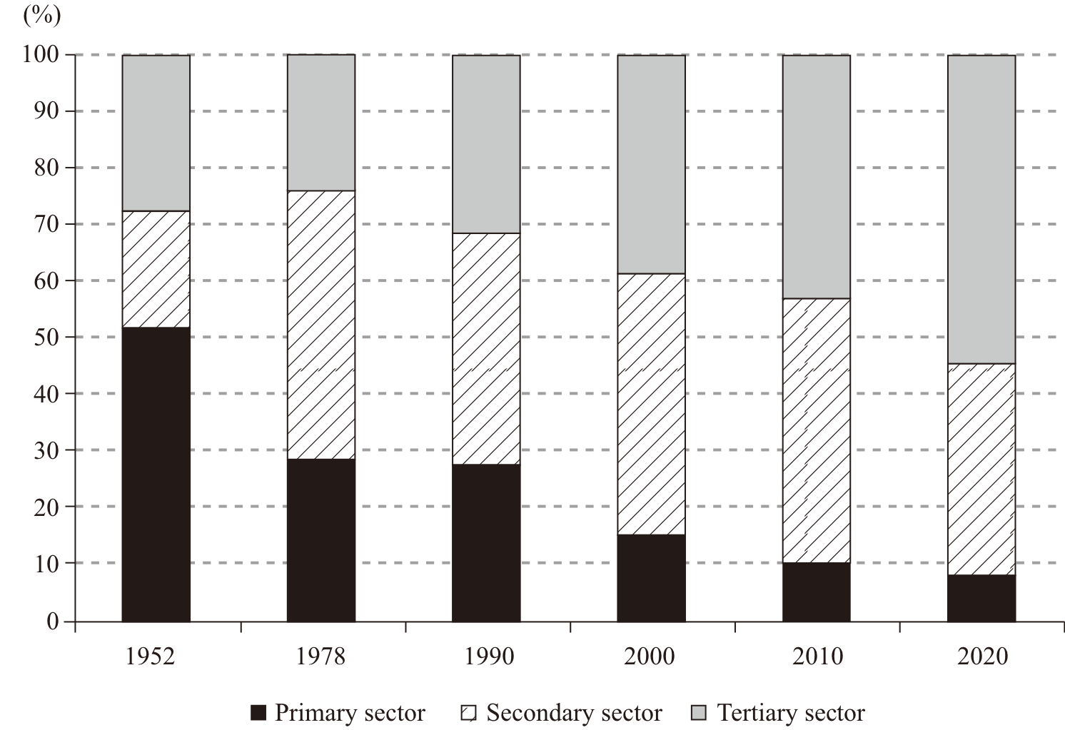

The digital economy has unleashed the vigor of businesses. Digital transformation of traditional industries and growth of the digital industry are both making headway. Modern service industries are picking up speed. New forms and models of business based on the internet continue to emerge. The platform economy and the sharing economy are booming. Producer services have become more specialized and moved up the value chain, while consumer services are better targeted and of higher quality.
The steady improvement and upgrading of the industrial structure has promoted balanced and extensive economic development. Consumers’ needs for individualized, high-quality and diverse supply are being met.
Modern infrastructure networks have been improved. Thanks to efficient information networks and an extensive network of roads, railways and bridges, temporal distance inside China has been significantly shortened, and it has become much easier to travel across the country, even on difficult terrain (Panel 2). An integrated transport network encompassing five north-south corridors and five east-west corridors connects the whole country. China leads the world in the total route length of high-speed railway, urban rail transit and expressway, and in the number of deep-water berths. For many years, its civil aviation sector has ranked second in the world in terms of total traffic turnover.
The country is quickly building itself into a leader in transport. Its extensive network has had a huge impact on the configuration of China’s cities, and on its population distribution, economic activities and even the life and work perimeters of the residents.
Energy supply capacity, development technology, and efficiency have continued to improve. A diversified high-quality energy production system has been established, concurrently driven by coal, oil, natural gas, nuclear power, and renewable energy.
Thanks to the constantly improving water resource management and infrastructure, China is able to support around 20 percent of the world’s population and 17 percent of the global economy with only 6.6 percent of the planet’s fresh water.
Progress in internet infrastructure has brought about wider service coverage, lower prices, faster internet speed, and easy connection anytime and anywhere. The information highway enabled by the internet has improved people’s lives.

Panel 2 Achievements in Infrastructure

China’s infrastructure network is among the largest in the world.
The country has built the most advanced railway and high-speed railway networks in the world. In 2020, it had 146,000 km of railway routes in operation, including 38,000 km of high-speed railways. China has the world’s largest expressway network, with a total length of 161,000 km.
China now has 22,142 quay berths in service, including a world-leading 2,592 berths of 10,000 tonnes or above. It also has the world’s longest navigable inland waterway system, reaching 127,700 km, and the highest inland waterway cargo transport volume. China has the world’s highest liner shipping connectivity index, with eight of the world’s top 10 ports based on cargo throughput, and seven based on container throughput. As a world leader in intelligent ports, China is renowned for the efficiency of its specialized terminals in major costal ports.
China has 241 civil airports nationwide.
The route length of China’s urban rail transit with high and medium passenger capacities is close to 6,700 km. More cities in China are opening metro services than in any other country in the world. The total network length of postal and express delivery service (one way) reached 52.8 million km.
Internet penetration has risen fast. By June 2021, China had put 960,000 5G base stations into service, and 5G terminal connections had surpassed 365 million. Fixed broadband penetration reached 96 percent, mobile broadband use was 108 percent, and the number of internet users topped 1 billion.
2. Expanding People’s Democracy
By achieving moderate prosperity in all respects, China has better ensured the economic and political rights of its people. The CPC leads the Chinese people on the socialist path of political advancement with Chinese characteristics. It upholds the unity of the Party’s leadership, the people’s position as masters of the country, and law-based governance, and is committed to developing whole-process people’s democracy. Democracy has thus grown from a set of values into a system, a governance mechanism, and a way of life rooted in the land of China. The Chinese people have become true masters of their country, society and future, and enjoy extensive, full and genuine democracy.
The people enjoy broad democratic rights. In China, all power of the state belongs to the people. The people engage in democratic elections, consultation, decision-making, management and oversight in accordance with the law (Panel 3).
The principles that apply in China’s direct and indirect elections are universal suffrage, equal rights, multiple candidates, and secret ballot. All citizens of the PRC who have reached the age of 18 – with the exception of those persons deprived of political rights in accordance with the law – have the right to vote and stand for election.
Socialist consultative democracy has experienced broad-based, multilevel and institutionalized development. Through various means and channels, the people are involved in extensive consultations on matters concerning reform, development and stability, especially those related to their vital interests, to reach the broadest convergence on the aspirations and expectations of society as a whole.
In making and implementing major decisions, the Party and the state solicit advice from all sectors of society, take account of public opinion, and pool the wisdom and strength of the people, in order to ensure democratic and sound decision-making.
The people participate extensively and directly in managing social issues, and local residents run their own affairs by serving the community and exercising self-education and public scrutiny.
In accordance with the Constitution and laws, the people have the right to offer criticism and make suggestions regarding any government office or employee. They have the right to level complaints, charges, or accusations against any government office or employee for violations of the law or dereliction of duty.
Democratic elections, consultation, decision-making, management and oversight are closely linked and integrated. There is a unity of democratic processes and democratic results, procedural democracy and substantive democracy, and direct democracy and indirect democracy, and the people’s rights to be informed, to participate, to express views, and to supervise the exercise of power are protected.

Panel 3 Whole-Process People’s Democracy

Among the deputies to the 13th National People’s Congress (NPC), frontline workers and farmers account for 15.7 percent, and all 56 ethnic groups are represented; in the 13th National Committee of the Chinese People’s Political Consultative Conference (CPPCC), non-CPC members account for 60.2 percent.
More and more women are participating in the decision-making and management of state affairs. There are 742 female deputies to the 13th NPC, accounting for 24.9 percent of the total; there are 441 female members in the 13th CPPCC National Committee, representing 20.4 percent of the total.
Since the 18th CPC National Congress in 2012, public opinion has been solicited on draft laws on 187 occasions, and more than 3 million comments from about 1.1 million people have been received, many of which have been adopted. During the drafting of the Civil Code, 10 rounds of public opinion solicitation were conducted, resulting in over 1 million comments from 425,000 people. During online solicitation for the preparation of the 14th Five-year Plan, over 1 million suggestions were received in two weeks. The NPC Standing Committee has established 10 local legislative outreach offices. By June 2021, these outreach offices had conveyed nearly 6,600 pieces of advice on 109 draft laws and legislative plans, many of which had been accepted.
The CPC Central Committee has organized or entrusted relevant departments to organize more than 170 consultative forums since 2012. On these occasions, it engaged in consultation with the other political parties and prominent individuals without party affiliation (non-affiliates) and solicited their opinions on matters of great importance such as the reports to the CPC national congress and plenary sessions of the CPC Central Committee and the formulation of the 14th Five-year Plan. The central committees of the eight non-CPC political parties and the non-affiliates have made more than 730 written proposals, many of which have turned into major state policies. From March 2018 – when the First Session of the 13th CPPCC National Committee was held – to June 2021, the CPPCC National Committee received 23,089 proposals.
In the fight against poverty, the CPC Central Committee entrusted central committees of the other eight political parties to monitor the process in eight central and western provinces and autonomous regions that faced onerous work in poverty alleviation. These parties made 36,000 interventions in democratic scrutiny over poverty alleviation actions, offered over 2,400 pieces of written advice to CPC committees and governments of the eight provinces and autonomous regions, and submitted more than 80 reports of various types to the CPC Central Committee and the State Council.

The Chinese people enjoy extensive democratic rights. They have the best understanding of China’s democracy, and they have the final say as to whether it works or not.
The CPC keeps attuned to the situation of the people, understands their needs, addresses their concerns, pools their wisdom, solicits their opinions, and asks for their advice. These are important means for the Party and the government to govern the country. In China, democracy is healthy, the people live in contentment, and society is full of vitality. On various matters including necessities of daily life, transport, health care, education, community management, social governance, state policies and development planning, the people can have their voices heard through democratic channels. Popular and original practices and forms of primary-level democracy continue to emerge, such as democratic discussions, hearings, online political deliberation, remote consultations, local legislative outreach offices, community councils and neighborhood meetings. This represents a general trend whereby matters concerning the core interests of the people are discussed and dealt with by the people themselves, and they make the decisions.
China’s democracy ensures that the people have channels to express their expectations, wishes and requests, to have their voices heard, and to receive feedback. This process effectively addresses the problems faced by the people, and conveys the aspirations of the whole of society, so that the whole nation unites as one and works together for common goals.
People’s democracy has an institutional guarantee. It mainly includes such systems as people’s congresses – which form the fundamental political system of China – CPC-led multiparty cooperation and political consultation, regional ethnic autonomy, and grassroots self-governance. Ensuring the people’s principal status as masters of the country, these systems have laid a firm institutional foundation for protecting the people’s interests.
The people exercise state power through the NPC and the local people’s congresses at all levels, which are responsible to the people and subject to their oversight. State organs are created by people’s congresses at each successive level and are responsible to them and subject to their oversight. People’s congresses at all levels are constituted through direct or indirect democratic elections. Their responsibility is to faithfully represent the interests and will of the people and to participate in the exercise of state power in accordance with the law.
Multiparty cooperation and political consultation under the leadership of the CPC is a new type of political party system, in which the CPC is the ruling party and the other parties participate in governance. It has realized unity between governance and participation in governance, leadership and cooperation, and consultation and oversight. It ensures that the people’s rightful claims are honored through a procedure guaranteeing the people’s status as masters of the country.
The system of regional ethnic autonomy guarantees the nation’s unity and solidarity, and ensures that all ethnic groups participate in governance. It fully protects the equal rights of all 56 ethnic groups and the power of self-governance in ethnic autonomous areas, underpins development in ethnic minority areas, and reinforces ethnic unity.
The system of grassroots self-governance enables the people to directly exercise democratic rights through multiple channels such as villagers committees and urban residents committees. This improves the effectiveness of community-level governance. The system of democratic management through employees congresses in enterprises and public institutions plays a positive role in protecting the lawful rights and interests of employees. It ensures they run their own affairs, brings vitality to these organizations, and helps them flourish and prosper.
The socialist legal system with Chinese characteristics, with the Constitution at the core, is improving, providing a solid legal guarantee for the people to play their role as masters of the country.
Social equity and justice prevail. The fundamental strategy of governing the country by rule of law has been fully implemented. China has succeeded in coordinating law-based governance, exercise of state power, and government administration, and in integrating rule of law for the country, the government, and society. Reform of the judicial system and mechanisms has advanced. The rule of law plays a greater role in representing the people’s interests, reflecting their wishes, protecting their rights and interests, and improving their wellbeing.
Social equity and justice – goals of the rule of law – are manifest in the whole process and every aspect of legislation, law enforcement, judicature, and law observance. The principle that judicial activities must serve the people is applied in full, and judicial credibility has seen a notable improvement. People can see for themselves that China is moving closer to the goal that equity and justice are served in every judicial case.
3. Flourishing Cultural Sector
In a moderately prosperous society in all respects, material progress should go hand in hand with advances in culture and ethics. The country’s economic strength and its cultural soft power should increase together. The people should have sufficient food and other daily needs, but they should also conduct themselves with dignity and a strong sense of morality.
Under the leadership of the CPC, the people have followed a socialist path of cultural development with Chinese characteristics, raising their awareness of and reinforcing their confidence in Chinese culture. The development of a great socialist culture has reshaped China’s national psyche. Chinese people now have richer cultural activities and greater inner strength, and they have changed their outlook in profound and positive ways.
The ideological foundations of collective endeavor are growing stronger. Socialism with Chinese characteristics and the Chinese Dream are heartily embraced by the nation. Popular support for the CPC, socialist system, and reform and opening up is running high; love of the country and ethnic unity resonate deeply with the people. The public has more confidence in the path, theory, system and culture of Chinese socialism. The core socialist values and the spirit of patriotism, reform, innovation and hard work are taking root among the people. Qualities of a mature citizenry prevail, including openness, inclusiveness, rationality, dignity, and the desire to excel.
The people’s heroes, role models, and iconic figures are the brightest stars of our time, and members of the public are more inclined to admire such individuals and become pioneers of progress. China’s revolutionary heritage has been carried forward, and revolution-themed tourism is gaining momentum. By revisiting their revolutionary past, people are motivated to refine their character and carry on the revolutionary faith.
The press, films, television programs, publishing, literary and artistic works, and cyberspace maintain the right tone in public communication, showing the enterprising spirit of mainstream society, creating a positive atmosphere for social development, unity and progress, and filling society with uplifting energy. All this has reinforced the cultural bonds shared by the Chinese and created a stronger sense of national identity among the people.
People are enjoying richer cultural activities (Panel 4). Public cultural facilities, ranging from rural reading rooms and cultural stations to urban libraries, museums, cultural centers, and art galleries, have been steadily improved, and are mostly open to the public free of charge or at a minimal cost. Public cultural services have become more diversified, equitable and convenient. With the appearance of digital libraries, cloud platforms and cloud museums, people can enjoy good-quality public cultural services in the comfort of their own homes.

Panel 4 Progress in the Cultural and Tourism Sectors

Public cultural services are more accessible. At the end of 2020, China had 3,212 public libraries, 618 art galleries, 5,788 museums, 3,327 cultural centers, 32,825 township-level cultural stations, and more than 575,000 village-level cultural service centers. All public libraries, cultural centers/stations, and art galleries and more than 90 percent of museums are open to the public free of charge. Radio and TV covered 99.4 percent and 99.6 percent of the population. There were 3.7 million sports venues in China, with a total floor area of 3.1 billion sq m (2.2 sq m per capita). The rural fitness program covered almost all villages.
The cultural sector is experiencing strong growth. At the end of 2020, China had 60,000 enterprises of designated size1 in the cultural industry, whose revenues for the year approached RMB9.9 trillion. Of this figure, 32 percent came from new business forms. There were 19 national-level cultural industry demonstration parks across the country. The added value of the cultural and related industries reached RMB4.5 trillion in 2020, accounting for 4.4 percent of GDP.
The supply of tourism products has increased. By the end of June 2021, China had opened more than 13,000 scenic areas of Grade A to Grade 5A (including 306 rated as 5A), 45 national and 583 provincial vacation resorts, 300 revolution-themed tourism destinations, and 1,299 towns and villages oriented to rural tourism.

The cultural sector is undergoing sustained, sound development, with new types of enterprise, new forms of business, and new models of consumption emerging at a faster pace. The online cultural industry is growing in strength. Stylish cultural venues, fine cultural products, and creative cultural events meet the demand for greater individuality and diversity, higher quality, and closer connections with the wider world.
The film, television and publishing sectors are booming. Blockbusters jostle for attention during the summer vacation, National Day and Chinese New Year holidays, and bestseller books hit the shelves in a steady stream, regaling citizens with a cultural feast. Effective measures have been taken to foster a wholesome social environment in the cultural and entertainment industries by combating undesirable phenomena. Cultural exchanges with other countries are expanding, enabling people to watch the best artistic performances from around the world without going abroad.
The cultural and tourism industries are more integrated and varied. Sightseeing trips, leisure tourism, farm tours and revolution-themed tourism meet people’s varying cultural and entertainment needs, and at the same time promote core socialist values. They introduce travelers not only to China’s beautiful landscape but also its splendid culture – an experience that both pleases the eye and nourishes the mind.
Public fitness programs are sweeping the country, in the form of both competitive sports and mass leisure activities. Competing for medals at international events or group dancing in parks – these programs help build healthier bodies as well as stronger bonds among the people. China is becoming a growing power in international sport.
Traditional Chinese culture is preserved and carried forward. Creative evolution and development have injected new vitality, continuing China’s cultural traditions, reinforcing its national spirit, and illuminating life in the new era.
More classics and classical arts such as Chinese operas, music, dancing, painting, and calligraphy have made their way into classrooms and become popular among the youth. From old artifacts in museums, historical sites, and texts of ancient books, to intangible cultural heritage passed down through generations, traditional culture is reviving and finding new appeal. Directly felt and experienced, it is becoming more accessible and comprehensible.
Archeological findings have produced more evidence of the origin and evolution of the Chinese civilization and its remarkable achievements. People are increasingly captivated by China’s classical arts and awed by its cultural treasures, which speak volumes about the deep roots of the Chinese civilization and the splendor of Chinese history. Celebrations of traditional holidays, including the Chinese New Year, the Lantern Festival, the Dragon Boat Festival, and the Mid-Autumn Festival, continue to observe old customs but also adopt contemporary elements adapted to modern life.
The concepts, values and moral norms of fine traditional culture are still espoused and practiced. They include benevolence, the people-centered approach, honesty, justice, harmony, unity in diversity, filial piety, love for one’s family, pursuit of progress, dedication to work, friendliness, advocating what is good and righteous, helping those in difficulties or danger, and acting bravely for a just cause. Rallied by traditional values, including patriotism, collectivism, unity and diligence, the Chinese people are standing stronger together.
The international appeal and influence of Chinese culture is growing. Traditional Chinese medicine, martial arts, Peking Opera, the tea ceremony and China-made films are now found in more countries. Chinese food, scenic sites, TV dramas, variety shows, online literature, and pop music are enjoyed globally. The 56 UNESCO world heritage sites in China are windows to understand the country’s past and present.
4. Improving People’s Wellbeing
A moderately prosperous society in all respects puts people first and places their wellbeing above anything else. The people are at the center of the philosophy of the CPC. Improving people’s lives and wellbeing is the Party’s goal as it continues to address their issues of major and immediate concern, and raise their sense of fulfillment, happiness and security. The Chinese people are now leading the decent life to which this nation has aspired for several thousand years. Their rights to subsistence and development are well protected. They have access to childcare, education, employment, medical services, elderly care, housing and social assistance.
People’s lives have been notably improved. Personal incomes have grown steadily, with the average per capita disposable income up from RMB171 in 1978 to RMB32,189 in 2020 (Chart 4). Quality of life has improved, with the Engel coefficient of urban residents down from 57.5 percent in 1978 to 29.2 percent in 2020, and that of rural residents down from 67.7 percent to 32.7 percent (Chart 5). Once their basic need for food and other daily necessities has been satisfied, people want a better life, including better food, clothes, housing, and travel facilities. Subsistence-based consumption is gradually giving way to a model directed towards greater fulfillment and comfort. People regard clothes not only as something that can protect them from the elements, but also as something that can make them look more attractive. Food serves not only to fill an empty stomach, but also to provide better nutrition and good health. People also aspire to live in bigger homes and better neighborhoods, and have faster and more comfortable transport. They are fully supplied with daily necessities and own a range of home appliances; car ownership is increasing rapidly. Consumption of services such as catering, health care, education, tourism, culture and entertainment has continued to surge, and now represents approximately half of China’s per capita consumer spending. More people have sufficient time and money to explore their dreams away from the hustle and bustle of daily life. Traveling no longer requires lengthy preparation and has added to the pleasures of life. China has entered the era of mass tourism.

Chart 4 Growth in per capita disposable income (1978-2020)

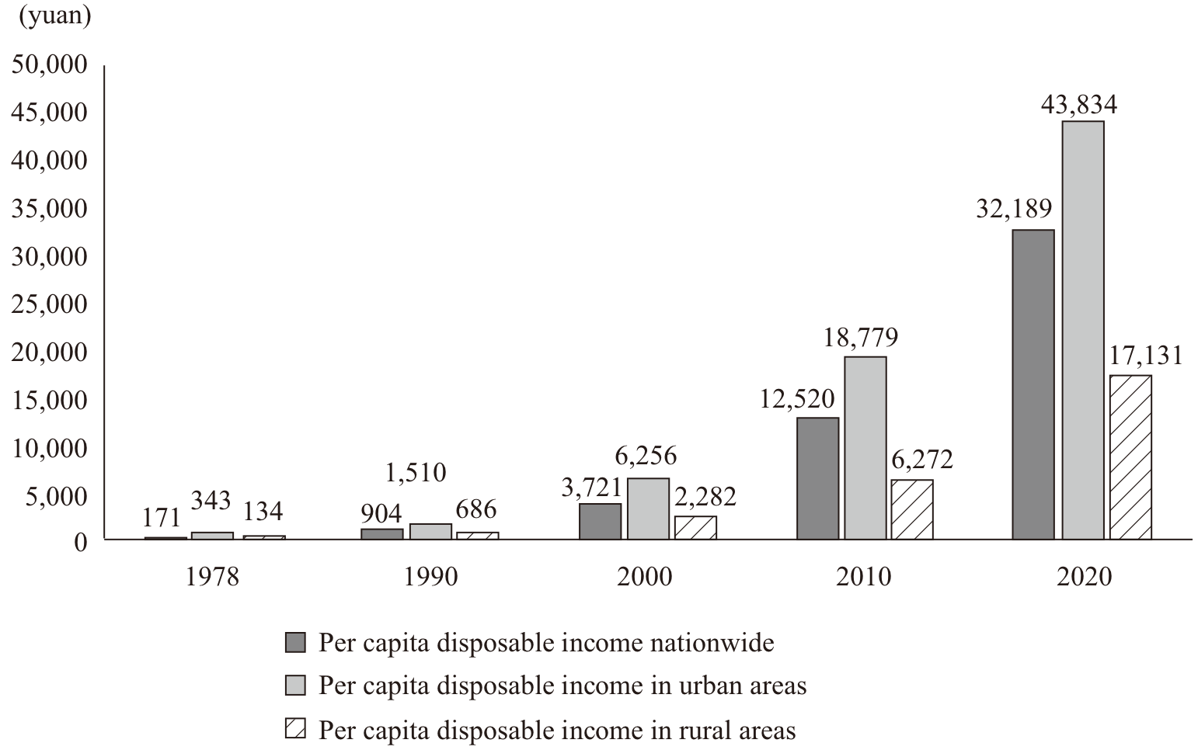

Chart 5 Engel coefficient of urban and rural residents (1978-2020)

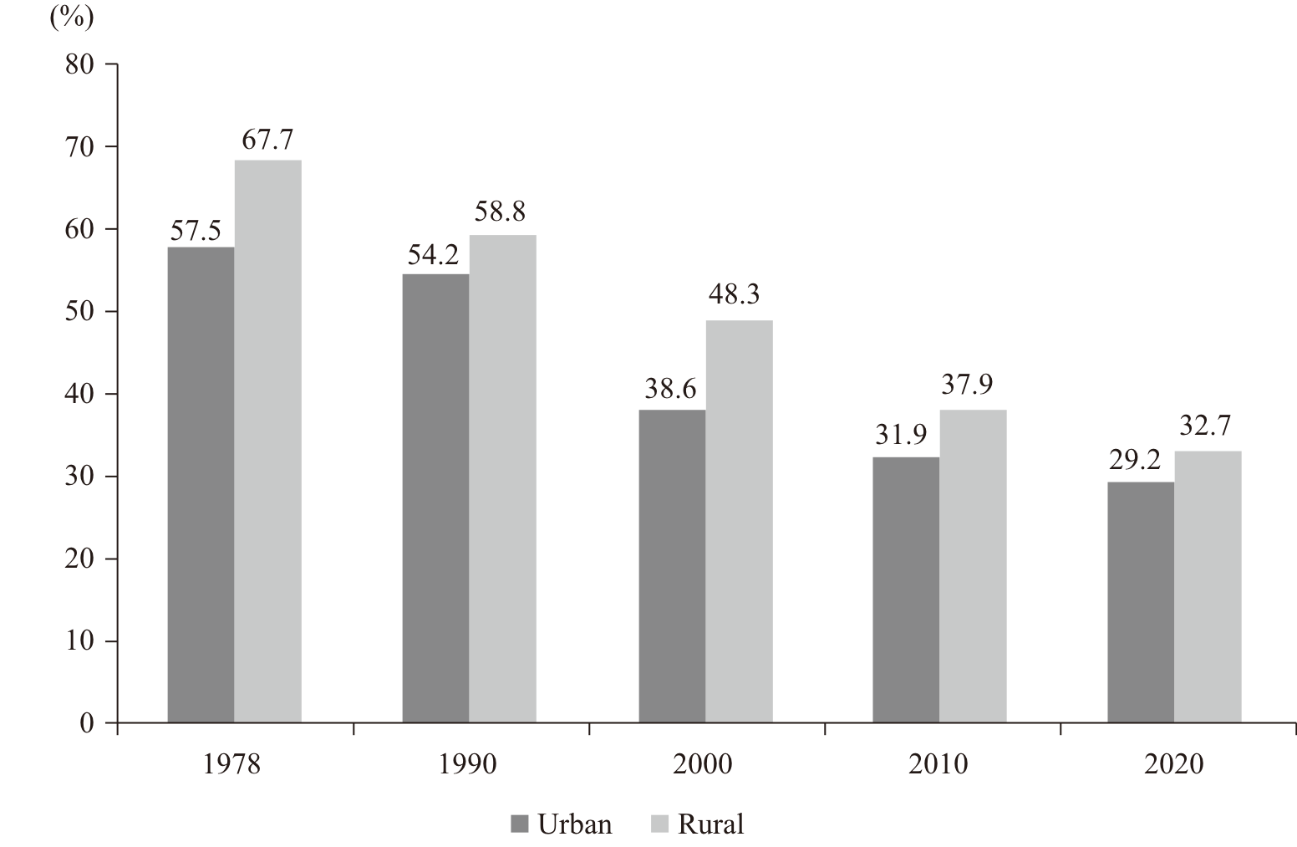

The job market remains stable and the quality of employment is rising. China’s employed population rose from 180 million in 1949 to 750 million in 2020. In the past, most working people were farmers. The employment structure has improved to the extent that 47.7 percent of the workforce are now employed in the tertiary sector (Chart 6), and 61.6 percent are working in cities (Chart 7). The working-age population, once mostly illiterate and semi-literate, now has an average of 10.8 years of schooling, and a higher-quality workforce is reflected in the fact that the number of skilled workers has reached about 200 million. Millions of people have found work they enjoy and work that can bring greater happiness to their lives. In the past, people were assigned to jobs. Now they can choose their career freely, based on market needs, or even start their own business. New forms of employment have emerged alongside traditional ones. This has brought a profound change to the mindset of the workforce, broadened their choices, and expanded the forms of employment available. Individuals can tie their interests, hobbies, skills and talents more closely to their job expectations, and to social demand and national needs. This has helped people to realize their personal values and further raised their initiative and their passion for creativity. The employed have seen their lawful rights and interests protected, their pay increased, and their incomes secured. More and more people can find work from which they can draw happiness and dignity. They are creating a better life with their own hands.

Chart 6 Changes in employment of primary, secondary
and tertiary sectors (1952-2020)

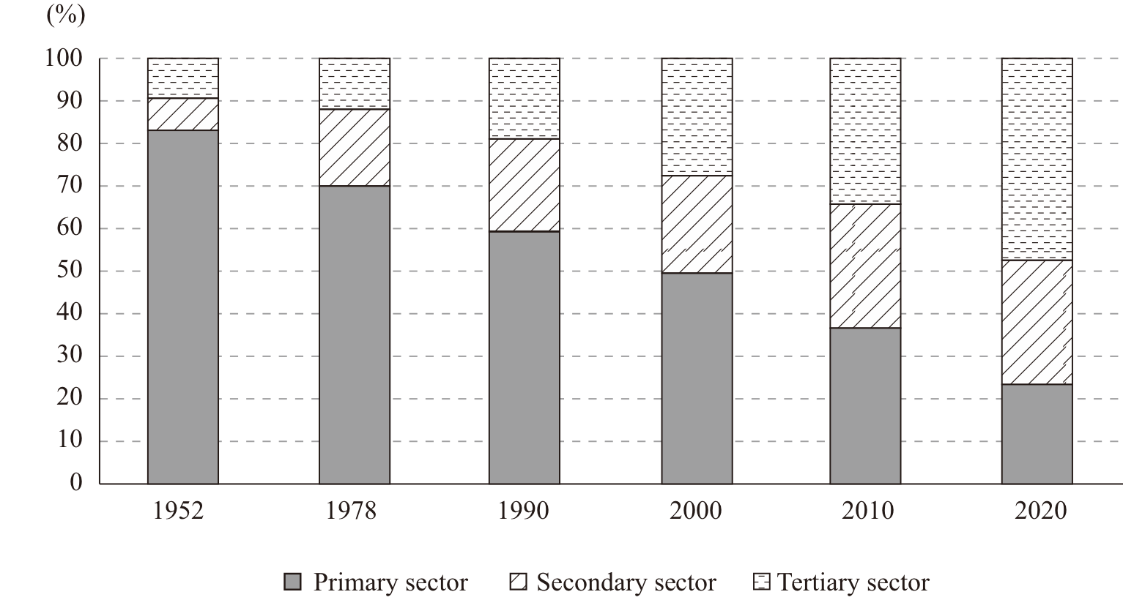

Chart 7 Changes in the urban and rural workforce from 1949 to 2020

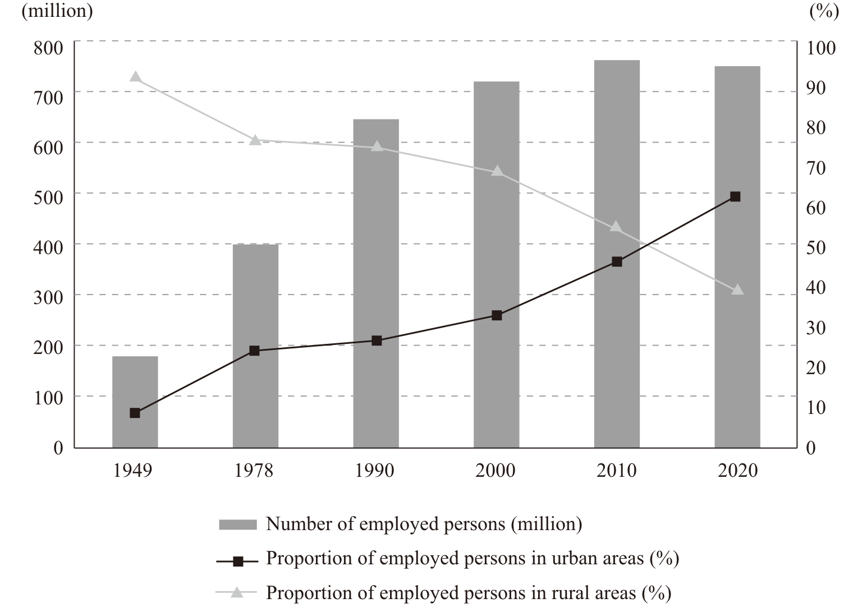

China’s policy has progressed from one day off to two days off per week and from the “golden week holidays” to paid annual leave. The rights of working people to rest and leisure are better protected, to help them balance work and life. The idea that work is a most honorable and noble activity has been welcomed, and is practiced by the great majority of the people, who believe that hard work is essential to success in life. The prevailing trend is to advocate, respect and value work.
Education is thriving. China has evolved from a populous country where a vast majority of people were illiterate or semi-illiterate, through one with significant education resources and a huge workforce, to one with high-quality education and human resources. It has established the world’s largest education system that spans preschool, primary, secondary, and higher education, ranking in the upper-middle category worldwide in terms of modern education (Panel 5 and Table 1). The enrollment rate in preschool education and the coverage rate of affordable preschool education have surpassed 84 percent, the completion rate of nine-year compulsory education has exceeded 95 percent, and senior secondary education is universally available across the country. Gaps in education between different regions, urban and rural areas, and different schools have all diminished. China’s basic education has progressed from providing access to schools and teachers to ensuring the quality of both, and a good and equitable education for all children is becoming a reality.
China’s universities and colleges have trained nearly 100 million high-caliber professionals. Enrollment in higher education is surging and the education level now ranks in the upper-middle category worldwide. Its vocational education institutions have trained a large number of highly skilled personnel and craftspeople. In the past, there was no provision of special education; now people with disabilities are guaranteed equal rights to education. A system for lifelong learning is under construction, augmented by internet and digital technologies and offering wide personal choices, and as self-improvement comes to be an everyday activity, a learning society for all is taking shape. Education in China has opened up paths for people to pursue a better life, changed their destiny, turned their dreams into reality, and presented them with more possibilities in life.
Social security covers all people. China has established the world’s largest social security system, comprising social insurance, social assistance, social welfare, and support for entitled groups – components of an inclusive, multi-tiered, and sustainable system that guarantees basic living needs. By the end of June 2021, the number of people covered by basic old-age insurance was 1 billion; unemployment insurance, 222 million; work-related injury insurance, 274 million; basic medical insurance, more than 1.3 billion. The law provides that maternity insurance covers all employers and employees.

Panel 5 Achievements in Education

In 2020, China had 537,100 schools at all levels and of various types, with 289 million students and 17.9 million full-time teachers. The gross enrollment rate in preschool education reached 85.2 percent, and the completion rate of nine-year compulsory education 95.2 percent. The net enrollment rate in primary education was just under 100 percent, the gross enrollment rate in junior secondary education 102.5 percent, and compulsory education realized balanced development in 96.8 percent of the counties nationwide. The gross enrollment rate in senior secondary education reached 91.2 percent, and that in higher education 54.4 percent. All primary and secondary schools in China had access to the internet, and 98.4 percent already had multimedia classrooms.

Table 1 Enrollment rate in education at different levels

 | 1949 | 1978 | 2000 | 2020
Gross enrollment rate in preschool education | 0.4% (1950) | 10.6% | 46.1% | 85.2%
Net enrollment rate in primary education | 20% | 94% | 99.1% | 99.96%
Gross enrollment rate in junior secondary education | 3.1% | 66.4% | 88.6% | 102.5%
Gross enrollment rate in senior secondary education | 1.1% | 35.1% | 42.8% | 91.2%
Gross enrollment rate in higher education | 0.26% | 2.7% | 12.5% | 54.4%

The country has strengthened housing security by building more than 80 million units of government-subsidized housing and housing for people displaced by urban transformation. It has also improved the housing conditions of more than 200 million poor people. Now, the vast majority of households with housing difficulties, either those entitled to subsistence allowances or those with low incomes, are covered in the system, and households with lower middle incomes have seen notable improvements in their housing conditions.
China has implemented a national strategy for addressing population aging, and is developing an old-age service network that coordinates home, community and institutional care, and combines medical care with maintaining good health. Most urban communities have provided home care services available within 15 minutes, which typically include meal preparation and delivery, medical services, and cleaning. More rural neighborhoods have built eldercare facilities such as nursing homes and day care centers. Affordable eldercare services and mutual-aid eldercare saw further development in both urban and rural areas. The elderly can now access professional eldercare in their homes or villages and have access to assistance, leisure, and places to settle.
China has ensured that the 85 million people with disabilities share the benefits of moderate prosperity as it steps up efforts to protect their rights and interests. The system for child welfare and the protection of minors has also improved, providing an effective shield for their healthy all-round growth.
The social security system is becoming more inclusive and offering people sustained guarantees at work, in life, and for their future.
Health care is ensured for all. In its early days the PRC was ravaged by disease and plagued by inadequate medical resources, but it is now capable of effective disease prevention and control, and of providing satisfactory medical services to its people. It has shifted its medical insurance policy from local reimbursement only to trans-regional settlement, and extended its medical services from hospitals only to care provided by growing numbers of contracted family doctors. These represent components of a sound medical and health care system with better allocated medical resources, and help to address the problems of difficult and expensive access to medical treatment (Panel 6).

Panel 6 Achievements in Medical and Health Care Services

Based on its national conditions, China constantly refines its three-level medical service network covering urban and rural areas, with disease prevention remaining the priority. It has given better access to medical services to one fifth of the world’s population. In 2020, the number of medical and health institutions in China exceeded 1 million, with 9.1 million beds and 10.7 million health professionals. A basic public health service system is in place, providing disease prevention and control, health education, maternal and child health care, and mental health care, among other professional services.
Equal access to basic public health services is supported by a per capita government subsidy that has increased from RMB15 in 2009 to RMB74 in 2020. Nineteen services including endemic disease prevention and treatment have been added to the 12 categories of basic public health services, provided to the public free of charge.
The average life expectancy in China rose from 67.8 years in 1981 to 77.3 years in 2019; infant mortality declined from 37.6 per 1,000 at the end of 1970s to 5.4 per 1,000 in 2020; and maternal mortality dropped from 43.2 per 100,000 in 2002 to 16.9 per 100,000 in 2020.

Medical technologies and service capabilities have risen as internet applications boost the sector. As part of its endeavor to ensure affordable and effective medical services, China has brought drug prices down to reasonable levels and regularly adds common drugs and life-saving drugs to the medical insurance list. There is no letup in the drive to provide equal access to basic public medical services in both urban and rural areas. A better medical and health care service system and a sound medical insurance system in rural areas have guaranteed medical services for rural residents, and helped prevent people from falling into, or back into poverty due to ill health.
The Healthy China initiative is part of the country’s effort to pursue fitness for all and health for all. The results can be seen in the form of lifestyles, approaches to work, and models of social and economic development and governance that are conducive to public health. In public health, China has steadily risen from an average world rating to the front ranks among middle-income countries. China’s fight against Covid-19 safeguards the life and health of the people, and its achievements in this battle bear witness to the strengths of China’s medical and health care system.
The public enjoy a greater sense of security. From “social management” to “social governance”, from “forming a well-designed and effective social management system” to “establishing a social governance model based on collaboration, participation, and common interests”, China has refined social governance within the framework of law by encouraging more public participation and applying the latest information technology to provide professional services.
The Peaceful China initiative has yielded remarkable results. Crime prevention and control is stronger, and measures extending to the “last kilometer” have given the public a greater sense of security and satisfaction. An intensified campaign has curbed organized crime, and the “protective umbrellas” that shelter them. The public welcomes a safe and stable environment backed by the authority of the rule of law.
Dispute prevention and problem solving at community level has significantly improved, with an approach under which trivial matters are handled at village level, major problems are settled at township level, and all disputes are addressed locally before they are passed up to the higher authorities. The open and IT-based system has been constantly improved, with grid-based management providing better service to the public and giving rise to a new style of community-level governance. Social governance in urban areas has also made steady progress.
China’s overall improvement in social management lifted the public’s sense of security to an impressive 98.4 percent in 2020. China maintains long-term social harmony and stability, allowing its people to live in peace and contentment in a country widely recognized as one of the safest in the world.
5. Historic Changes to the Eco-Environment
A sound eco-environment is the most inclusive contributor to people’s wellbeing, and a salient feature of moderate prosperity in all respects. To further the interests and wellbeing of both current and future generations, and guarantee China’s sustainable development, the CPC has decreed that lucid waters and lush mountains are invaluable assets. It has adopted a basic national policy of resource conservation and environmental protection, and worked hard to build a Beautiful China. Its endeavors have made the skies bluer, the lands greener, and the waters more lucid across the vast and beautiful landscape of the country, and added more green touches to the planet that is home to us all.
China has formulated and enforced stringent systems for eco-environmental protection. It applies the principles and methods of the rule of law into practice in promoting eco-environmental progress. By enacting the strictest Environmental Protection Law in its history, and formulating or amending a range of other laws and regulations, it has created a legal framework on the eco-environment that covers all environmental factors in major fields.
China has established a series of eco-environmental protection systems in areas such as efficient use of resources, conservation and restoration, lifelong accountability for damage, responsibility for and performance evaluation of targets, and central government supervision. The most rigid possible constraints imposed by these stringent systems have resulted in better outcomes in changing the development model, fostering eco-friendly habits among the people, and promoting environmental protection and governance.
China has implemented the system of “river chiefs”, “lake chiefs”, and “forest chiefs” across the country, managing its river courses carefully as if they were sub-districts in urban areas, and protecting its reservoir areas with the same care as scenic resorts. As a result, designated personnel are in place to tend mountains, plant trees, protect forests, and take on related responsibilities, thus establishing lasting governance of the eco-environment.
China has involved the whole of society in eco-environmental protection. A better system has been established for public participation, including decision-making, scrutiny, and reporting on environmental violations; environment-related information has become more transparent; and public awareness of environmental protection has been raised. The people have therefore benefited from green development while contributing to eco-environmental progress.
China has made strong headway in preventing and controlling pollution. In its drive to keep the skies blue, the waters clear, and the land pollution-free, China achieved the following in 2020:
• In cities at or above prefecture level, 87 percent days reached good or excellent air quality.
• In cities at or above prefecture level that fell short of the national standards, average PM2.5 concentrations decreased by 28.8 percent from 2015.
• The proportion of excellent and good-quality surface water reached 83.4 percent.
• Up to 94.5 percent of the drinking water sources serving urban communities reached the required standards.
• Black and foul water bodies in urban built-up areas at or above the prefecture level were largely eliminated.
• Approximately 90 percent of polluted farmland and more than 93 percent of polluted land plots were rendered safe for use.
• The target of bringing down the imports of foreign solid waste to zero was achieved as scheduled.
In a more beautiful living environment with fresher air, cleaner drinking water, and safer food, the people have enjoyed the pleasures brought by environmental improvements, and registered greater satisfaction with the improved eco-environment and a stronger sense of gain. In 2020, 89.5 percent of Chinese people were satisfied with the eco-environment.
China has improved the health and stability of its ecosystems. Prioritizing resource conservation and environmental protection, and letting nature restore itself, the country has protected and managed its mountain, river, forest, farmland, lake, grassland, and desert ecosystems with a holistic approach. It has improved its management and inspection systems for nature reserves and eco-environmental protection zones, thereby strengthening eco-environmental security and ensuring China’s sustainable development (Panel 7).

Panel 7 Examples of Eco-Environmental Progress

Saihanba Mechanized Forest Farm
Since its inception in 1962, the Saihanba Mechanized Forest Farm in Hebei Province has created a miracle from wasteland to woodland, thanks to the hard work and dedication of generations of local people. Compared with the early years, its forest area has risen from 16,000 ha to 77,000 ha, its forest stock has surged from 330,000 cu m to 10.4 million cu m, and its forest coverage rate has soared from 11.4 percent to 82 percent. The farm can conserve and purify 274 million cu m of water, sequestrate 814,100 tonnes of carbon, and release 570,600 tonnes of oxygen every year. Since its founding, the forest farm has accumulated RMB20.6 billion in total assets from an investment of RMB1.8 billion, and elevated its annual revenues from less than RMB100,000 to RMB160 million. Its employees now earn an average annual income of RMB100,000. The forest farm also benefits more than 40,000 people in its community, and has helped 22,000 people move out of poverty. It received the Champions of the Earth award from the UN in 2017.
Shelterbelts in northeastern, northern and northwestern regions
China launched this project in 1978 as a fundamental action to counter the sandstorms and soil erosion in these regions. The project spans 13 provinces and autonomous regions covering a total area of close to 4.1 million sq km, or 42.4 percent of China’s land mass. It is scheduled to continue for 73 years through 2050, and plans to develop 35.1 million ha of forests, of which 26.4 million ha, or 75.1 percent, are earmarked for man-made forests. The largest forestation project in the world, it will increase forest coverage in these regions from just over 5 percent to just under 15 percent, effectively curbing sandstorms and containing soil erosion. By the end of 2020, the area of planted trees had increased to 30.1 million ha, and the project areas had seen a rise in their forest coverage to 13.6 percent, and a boom in their forestry, fruit industry and ecotourism, among many other environmental, economic, and social benefits.
Zhejiang’s Green Rural Revival Program
It has taken the concept that lucid waters and lush mountains are invaluable assets and put it into sound practice in rural areas. The province started the overhaul of its rural environment in 2003, with a major effort to improve the quality of work and life of rural residents, and especially the eco-environment. The target was to thoroughly improve the environment in approximately 10,000 of its total 40,000 administrative villages in five years, and develop around 1,000 of them into demonstration zones for moderate prosperity in all respects. Through resolute efforts, the program has delivered remarkable outcomes – building up thousands of beautiful villages and making Zhejiang Province the best in the country in terms of rural living environment. It received the Champions of the Earth award from the UN in September 2018.

Through wide motivation and four decades of continuous effort, China has turned forestation and greening into a voluntary activity involving the whole of society. Extending its man-made forests to a total area of 79.3 million ha nationwide, China has transformed deserts into oases, and carpeted the Loess Plateau with greenery. The country has the highest growth in forest resources and the largest area of man-made forests in the world. By the end of 2020, it had raised its forest coverage to 23 percent of its land mass and the vegetation coverage of its grasslands to 56.1 percent, and brought over 50 percent of its wetland areas under protection.
In addition, China has set up a system for eco-environmental protection zones, safeguarding its biodiversity with natural reserves at different levels and of various types now covering 18 percent of the country’s land mass. The people can experience more picturesque natural scenes with beautiful mountains, clear waters, green grass, colorful flowers, singing birds, and buzzing insects.
The effort to build national forest cities continues to intensify, turning “forests in cities” into a reality. A total of 468 cities have been part of the greening movement, and vigorous steps to this end have raised the green space to 38.2 percent of urban built-up areas, and the per capita urban park green space to 14.8 sq m. All of this heralds a Beautiful China where the people take care of and live in harmony with nature.
China is embracing a green path to development and a green way of life. As the concept that lucid waters and lush mountains are invaluable assets gains more public support, the whole country has gradually shifted to a path of prioritizing eco-environmental conservation and pursuing green and low-carbon development. It is now moving faster towards an energy-conserving society, with a configuration of land use, an industrial structure, a production model, and a way of life that underpin resource conservation and environmental protection. The economic structure and the energy mix are undergoing constant adjustments, the use of territorial space is improving, eco-friendly sectors such as environmental protection, clean energy, and clean production are thriving, the transition to green and low-carbon development is accelerating, and economic and social development is advancing in parallel with eco-environmental protection.
China tops the world in terms of new energy use and progress in energy conservation. Between 2015 and 2020, its energy consumption per unit of GDP fell by 13.2 percent and carbon emissions dropped by 18.8 percent. Through a range of initiatives including the “toilet revolution” in villages, domestic waste disposal and sewage treatment, domestic waste sorting, treatment of black and foul water bodies in cities, and construction of urban parks, green spaces, and greenways, people in both urban and rural settings now live in a cleaner, more comfortable, and more beautiful environment.
Urban public vehicles, mainly buses and subways, carry over 200 million passengers every day. Roads and facilities friendly to cycling and walking are expanding in urban areas, and more people are favoring green and low-carbon modes of transport. In addition, tens of thousands of households are practicing thrift through actions such as saving food, water, paper, and energy, choosing eco-friendly materials for home decoration, and saying no to over-packaging and disposable products. The nation is turning towards a thrifty, green, low-carbon, and healthy lifestyle.

III. Prosperity for All
A moderately prosperous society in all respects is a society in which all people share the fruits of development, a society where no individual, region or ethnic group is left behind, and a society that promotes the well-rounded development of all. Each of these is essential for achieving common prosperity, a major goal of socialism. China has now succeeded in creating such a society, where the people from all 56 ethnic groups enjoy a happy and comfortable life in every corner of China’s vast land.
1. Prosperity for Every Individual
China is the largest developing country in the world. The country was long plagued by weak foundations, uneven development, and poverty. Unless every poor person and all poor areas could rise out of poverty, moderate prosperity in all respects would be impossible.
Led and united by the CPC, the Chinese people have fought a steadfast war against poverty. After its 18th National Congress in 2012, the CPC made the elimination of regional poverty and absolute poverty in rural areas its basic objective and the defining indicator for achieving the First Centenary Goal, and has secured a complete success.
China adopted a targeted strategy to help poor people rise out of poverty and achieve moderate prosperity along with the rest of the country. Targeted efforts have been made in six areas:
• identifying the poor accurately;
• arranging targeted programs;
• utilizing capital efficiently;
• taking measures targeting individual households;
• dispatching officials based on conditions in individual villages;
• achieving the set goals.
Five measures for poverty eradication have also been taken:
• boosting the economy to provide more job opportunities;
• relocating poor people from inhospitable areas;
• compensating for economic disadvantage associated with reducing environmental damage;
• improving education in poor areas;
• providing subsistence allowances for those unable to escape from poverty through their own efforts.
By the end of 2020, all of the 99 million rural poor, and all of the 832 counties and 128,000 villages classified as poor under China’s current poverty line, had emerged from poverty.
The government has substantially reduced poverty in ethnic minority groups and areas. By the end of 2020, a total of 31.2 million people had been raised from poverty in the five autonomous regions of Inner Mongolia, Guangxi, Tibet, Ningxia and Xinjiang, and the three provinces of Guizhou, Yunnan and Qinghai, where many ethnic minorities live. All members of the 28 ethnic groups, with populations below 300,000, had risen out of poverty, and the ethnic groups which made the direct transition from a primitive to a socialist society in the early years of the PRC experienced another dramatic transformation – from absolute poverty to moderate prosperity.
The incomes and welfare of the registered poor in rural areas have improved substantially. Adequate food and clothing, and access to compulsory education, basic medical services and safe housing have been guaranteed for them. Improvements in education, health care, housing, and access to safe drinking water and other amenities have met their basic needs and also laid the foundations for their future development (Panel 8).
Since 2016, more than 9.6 million people registered as living below the poverty line have been lifted out of poverty through relocation from places that are inhospitable for them to make a decent living.

Panel 8 A Substantial Rise in Living Standards for the Poor

Incomes have increased rapidly. The per capita disposable income of rural residents in poor areas reached RMB12,588 in 2020. This represents a compound annual growth rate of 9.2 percent in real terms from 2013 to 2020, 2.2 percentage points higher than the average growth for rural residents nationwide. Formerly impoverished households now have adequate food, clothing and bedding for every season and all weather conditions.
Their ability to keep themselves free from poverty has steadily increased. The government has created more jobs through multiple channels and carried out large-scale vocational skills training, helping over 30 million impoverished people to find jobs. In all, 93.8 percent of registered poor households have benefited from employment assistance policies. More than two thirds of registered poor people emerged from poverty by entering the workforce, and their number rose from 15.3 million in 2016 to 32.4 million in 2020.
Compulsory education is available for all school-age children. The 200,000 children from registered poor households who dropped out of compulsory education were all identified and helped back to school in a timely manner. The chronic dropout problem among the registered poor had thus been solved. In 2020, the nine-year compulsory education completion rate in poor counties reached 94.8 percent. Since 2012, a total of 5.1 million students from registered poor households have received higher education, with millions of these households seeing the first family member ever to attend a university. During this period, key universities recruited a total of 700,000 students from rural and impoverished areas through a targeted program.
Basic medical services are guaranteed for the poor. The three-tiered medical services system at village, township and county levels has been steadily improved. Measures have been taken to provide medical treatment to those with major illnesses, and ensure contracted health care for those with chronic illnesses. Almost all now have access to basic medical insurance, major illness insurance, and medical assistance. Under these arrangements, approximately 80 percent of the hospitalization and outpatient expenses for treating chronic or special illnesses can be reimbursed. These developments have increased the availability and lowered the cost of medical care and effectively reduced health-related poverty.
Safe housing has been guaranteed. Through a poverty-alleviation program to renovate substandard rural houses, 25.7 million poor from 7.9 million households have had their dilapidated dwellings renovated. Meanwhile, housing improvement assistance has been provided to 10.8 million rural households experiencing economic difficulties, including households entitled to subsistence allowances, people cared for in their homes with government support, and families with members suffering from disabilities. A total of 23.4 million registered poor households have moved into safe homes which are more comfortable and offer better protection against earthquakes and other natural disasters.
Access to safe drinking water has been ensured. An upgraded program to improve drinking water safety has been launched in rural areas, providing adequate supplies of drinking water that meet the relevant standards to 382 million people, including 28.9 million formerly living in poverty. Tap water coverage in poor areas increased from 70 percent in 2015 to 83 percent in 2020.

The battle against poverty has inspired people to strive for a better life and built up their confidence and determination. Those who have risen out of poverty are inspired to seek prosperity through hard work, self-reliance, thrift and entrepreneurship.
After eradicating absolute poverty, China has been conducting follow-up monitoring for those areas and people who have newly escaped poverty, and has set a grace period during which assistance and other supportive policies will continue. Through regular inspections and dynamic management, problems can be spotted as soon as they arise, and intervention and assistance can be carried out promptly. These areas have been equipped to generate their own capacity for development, and people recently emerging from poverty have been motivated to invest their own efforts, so that they will not fall back into poverty.
The rights of special groups to subsistence and development have been effectively guaranteed. Preferential policies have been adopted to reinforce support, improve their welfare, and increase their access to development opportunities.
The basic national policy of gender equality has been universally applied. Women have been a prioritized target group for poverty alleviation and reduction. China has adopted preferential policies, allocated funds, and implemented targeted measures to help poor women address their pressing problems. Women account for about half of the 99 million people who have emerged from poverty.
China has implemented the National Development Plan for Children in Poor Areas (2014-2020) to ensure the education and health of children in poor areas and make any necessary interventions. The Nutrition Improvement Program for Children in Poor Areas has been implemented. In 832 counties formerly classified as impoverished at national level, the government provides a free daily pack of dietary supplements rich in proteins, vitamins and minerals to every baby aged 6-24 months, benefiting a total of 11.2 million children. Volunteers have been organized to provide paired care and assistance to orphans, left-behind rural children, and other children in need. The government has strengthened the guarantees for the basic needs of orphans and improved care for all children in need.
China has promptly increased the premium of basic old-age insurance and pension for both urban and rural residents. A system of care and services for left-behind rural seniors has been established. Care for poor seniors who cannot carry out essential self-care has been strengthened. The government has ensured seniors’ basic living standards and their access to essential services.
China has guaranteed basic needs and services for people with disabilities, helping more than 7 million poor disabled people out of poverty. Their special needs are now better met, and significant progress has been made in providing better nursing services for poor people with severe disabilities.
2. Integrated Urban-Rural Development
In a moderately prosperous society, urban-rural development is more balanced and people-oriented urbanization is advancing, while the salient problems of agriculture, rural areas and rural people are being addressed. The urban-rural divide is being narrowed, the development gap between urban and rural areas continues to shrink, and integration has increased. Like two wheels of a cart, urban and rural areas complement each other and advance side by side.
Rural areas are becoming increasingly prosperous. With the implementation of the rural revitalization strategy, agriculture is being upgraded, rural areas are developing, and rural people are experiencing improvements in every aspect of life. Agricultural modernization is accelerating, and the supply of grain and other important agricultural products has been secured. China’s annual grain output has remained above 650 million tonnes for the last six years. Its output of fruits, vegetables, tea, meat, eggs and fish all rank top of the world. Its comprehensive agricultural production capacity has been steadily increasing, and the contribution of scientific and technological advances to agricultural production has surpassed 60 percent. The overall level of mechanization in tilling, sowing and harvesting has reached 71 percent. The Chinese Farmers’ Harvest Festival has been created so that farmers have their special day. The grain-dominated agricultural economy has been replaced with a more diverse rural economy featuring agriculture, forestry, animal husbandry and fisheries, and integrated development of primary, secondary and tertiary sectors. The roles of agriculture and rural areas continue to expand. Emerging industries and new business forms, such as eco-agriculture with distinct local characteristics, rural e-commerce, rural tourism, leisure agriculture, cultural experiences, and health care for seniors, are growing faster and bringing all-round development to the rural economy.
Rural infrastructure has been strengthened. Almost all administrative villages have access to surfaced roads, three-phase electric power, and 4G cellular networks. Rural logistic services are steadily improving. Express delivery stations have been set up in every town and township; they are spreading quickly into villages. More and more villages have purified water sources, surfaced roads, street lighting, clean energy, and a beautiful environment (Panel 9). The modernization of rural houses and villages is continuing, and the “toilet revolution” has produced obvious results. Many remote and once-impoverished villages have been completely transformed. Graced with village parks and home gardens, they have become better places to live and work in.
Illiteracy among rural youth and the middle-aged has been eliminated. Nine-year compulsory education has been consolidated, with the quality improving steadily. Rural people are significantly better educated. The Healthy Villages program has been rolled out, and village clinics have become more standardized and their health management ability has improved. The health level and life expectancy of rural residents have significantly increased. Rural cultural activities have become more colorful, and villagers can enjoy the facilities in rural reading rooms, cultural halls and fitness spaces.
Rural people are more open-minded, and are increasingly familiar with modern concepts such as innovation, science and technology, law and the market. They now pursue scientific, healthy and civilized new ways of life which are simple, thrifty, eco-friendly, and hygienic. Good social practices, including modest weddings and funerals, practicing filial piety, and helping the needy, the weak and the disabled, have been promoted. A new society blending rural traditions with modern style is taking shape. More beautiful, harmonious, livable and flourishing villages across the country are benefiting from a cleaner environment. The goals to make agriculture strong, rural areas beautiful, and rural people prosperous are being realized.

Panel 9 Achievements in Rural Infrastructure

High-quality rural roads that are properly built, managed and maintained, with well-operated passenger and freight services, have made a solid contribution to eliminating poverty and creating moderate prosperity in rural areas. By 2020, all the villages, towns and townships where conditions permit were accessible by surfaced roads and served by buses. Now 62.6 percent of rural households are supplied with purified tap water, 46.2 percent of rural households use gas or liquid gas for cooking, and 68 percent of rural households are equipped with sanitary toilets. More than 90 percent of administrative villages have access to domestic waste collection and disposal facilities. More than a quarter of rural households have their domestic sewage effectively treated. Some 80 percent of administrative villages have agriculture-related information service stations.

Urbanization is increasing. Urbanization is the only route to modernization and moderate prosperity. Before the founding of the PRC, cities and towns, usually declining and rundown, were few and far between. Today, they are spread across the country, bustling with life and modern amenities.
China has gone through the broadest and fastest urbanization process in the history of the modern world. From 1949 to 2020, the percentage of permanent urban residents in the overall population rose from 10.6 percent to 63.9 percent, and the number of cities grew from 132 to 687, while the number of administrative towns soared from 2,000 to more than 21,000. Widely distributed, these cities and towns are of various sizes, each with its own characteristics. They include modern and internationalized metropolises, grandiose ancient capital cities, glamorous cultural destinations, and towns with unique features. As urbanization accelerates, tightly-knit city clusters have formed, each covering a large area and inhabited by a large population. They are becoming powerhouses driving economic development, modernization, and the improvement of urban operational efficiency and their residents’ living standards.
A multi-tiered modern urban system has taken shape, composed of city clusters, metropolitan areas, cities of all sizes, and towns, all developing in tandem.
People-oriented new urbanization is accelerating. As places where people can enjoy high-quality life, Chinese cities are becoming more livable, innovative, smarter, greener, more people-centered and resilient. With advanced water, electricity, gas, road, internet and other infrastructure, cities are safer and better able to ensure that residents’ basic living needs are met (Panel 10). Employment is more diverse and opportunities are more equitable, education resources are better and more balanced, the medical care system is more mature and advanced, and shopping and traveling are easier and smarter. Many more people are settling in cities and the living standards of urban residents continue to improve.
Libraries, museums, art galleries, exhibition halls, gymnasiums and stadiums, culture centers, cinemas and theaters have grown in numbers and quality. Public reading activities, urban public cultural spaces, and the application of digital, internet and smart technologies in public cultural services and products have all developed at a faster pace. Basic public cultural services in cities have become more accessible, better in quality and more customized. People’s diverse and higher-level needs are satisfied. During the day, cities are abuzz with activities, while at night they glitter with color. Night markets, night performances, late-night bookstores, light shows, and round-the-clock convenience stores have mushroomed, fueling night life, night culture, and the night economy, so that people can enjoy quality after-work life.
The urban environment is improving. Urban dwellers’ dreams of living in places with mountains and waters reminiscent of their pastoral roots have come true. Urban planning is more people-oriented. Working, living and environmental spaces are divided more clearly and more rationally. City planning attaches greater importance to the preservation of historical sites and cultural traditions. The Chengdu-Chongqing economic circle is taking shape and growing fast, becoming an important engine driving the country’s high-quality development. The construction of the Xiong’an New Area has picked up speed, and it is emerging as a future city vital to the country’s long-term development and an icon of socialist modernization.
A new urban-rural relationship is taking shape. Urban development has boosted rural development, and vice versa. The flow and transfer of factors of production between urban and rural areas, including labor, capital, technology and data, has become smoother. Cities have gradually lifted restrictions on household registration, while policies to promote the flow of talent, capital and technology from urban to rural areas have been formulated or improved. The development potential of rural areas and agriculture is being unleashed. Reform is under way to establish a uniform urban-rural household registration system. It is becoming easier for people moving from rural to urban areas to gain permanent urban residency. From 2016 to 2020, about 100 million people were granted permanent urban residency. A residence permit system has been implemented, under which permanent urban residents are increasingly covered by basic public services such as compulsory education, medical and health services, skills training, and social security.

Panel 10 Achievements in Urban Infrastructure

By 2020, there were 459,200 km of urban roads, and 704,000 buses and trolley buses in service. Meanwhile, 99 percent of China’s urban residents had access to tap water and 97.9 percent to natural gas; centralized heating covered 9.9 billion sq m; urban sewage pipelines stretched 803,000 km. The sewage treatment rate reached 97.5 percent, and 99.7 percent of domestic waste was subject to harmless disposal; vegetation coverage was 2.4 million ha in urban built-up areas, with a coverage rate of 42.1 percent.

Rural residents have more options in both urban and rural areas. They can either stay in the rural areas where they have fields to till and homes to live in; or go to cities where they can find work and enjoy other benefits. Later they can return to their hometowns to start their own businesses assisted by favorable policies.
The income gap between urban and rural residents has been further narrowed. The urban-rural disposable income ratio has declined steadily for 13 years since 2008, to 2.56:1 in 2020. Urban and rural infrastructure has become better connected and integrated, and transport between urban and rural areas is smoother and more convenient. Unimpeded delivery of manufactured goods into rural areas and agricultural products into cities has effectively boosted rural incomes.
Measures have been taken to make up for deficiencies in county seats, as more and more rural residents choose to become urbanites in nearby county towns. Flourishing agritainment, eco-tourism, and village home stays are attracting many more urban residents to spend holidays in rural areas, while a growing number of migrant workers have returned to their hometowns to start businesses, injecting new momentum into rural revitalization.
Nowadays, cities and towns boost rural and agricultural development with talent, capital and technology, meet the mounting rural consumer demand, and provide rural migrants with more job opportunities and better basic public services. The rural areas supply better and healthier produce to urban residents, provide a big consumer market and labor supply for urban development, and attract a larger number of urban residents to work and start businesses there. A new type of urban-rural relationship is taking shape, featuring mutual benefit, common prosperity, and coordinated and integrated development.
3. Coordinated Development Across Regions
China has a vast territory and a large population, and its natural resources vary greatly from region to region, resulting in developmental imbalances. Following decades of hard work, substantial progress has been made in coordinating the development of different regions. Major initiatives have been implemented to support the pioneering role of the eastern region, develop the western region, revitalize the northeast, and spur the rise of the central region. In addition, new regional strategies – to coordinate development in the Beijing-Tianjin-Hebei Region, develop the Yangtze River Economic Belt, build the Guangdong-Hong Kong-Macao Greater Bay Area, integrate development in the Yangtze River Delta, and strengthen eco-environmental conservation and high-quality development in the Yellow River Basin – have achieved substantial success. The strategic and institutional framework for functional zoning has improved.
These initiatives and strategies have resulted in a better configuration of China’s territorial space, with clearly defined functions for each area, and reinforcing connectivity and complementarity between the regions.
The new regional strategies have yielded concrete results in coordinated regional development. China has taken solid steps to coordinate development in the Beijing-Tianjin-Hebei Region. To this end, it has carried out the following initiatives:
• developing the Xiong’an New Area in Hebei and the Beijing Municipal Administrative Center in eastern suburban Beijing;
• building an integrated rail network in the region;
• integrating the prevention, control and treatment of pollution;
• facilitating industrial upgrading and relocation;
• optimizing the regional mechanism for coordinating development;
• providing equal access to basic public services.
Orderly progress has been achieved in relieving Beijing of functions that are not essential to its role as the national capital. Spatial and economic configuration has been improved to make the region more dynamic.
In developing the Yangtze River Economic Belt, China has prioritized eco-environmental conservation and green development, and stepped up joint efforts to prevent overdevelopment. It has applied measures of unprecedented intensity, scale and impact to restore ecosystems and make economic and social development more eco-friendly in the Yangtze River Basin. As a result, the region’s eco-environment has improved considerably, as has its economic and social development.
China has made steady progress in developing the Guangdong-Hong Kong-Macao Greater Bay Area, and in expanding infrastructure and policy connectivity between the three locations. The composite strength of the area has been reinforced through expanding regional cooperation and building an open economy aligned with international standards.
The integration process in the Yangtze River Delta involves policy coordination, industrial cooperation, co-development of infrastructure, a rational division of functions, and shared access to public services. The region has developed into a dynamic growth pole in China and a national pacesetter in high-quality development, integrated regional development, modernization, reform and opening up in the new era.
The Yellow River Basin has made solid initial progress in eco-environmental conservation and high-quality development through restoring ecosystems and transforming growth drivers. The region is reinforcing its role as a major ecological shield and forming a distinctive economic configuration that taps into local strengths.
The eastern, central, western and northeastern regions of the country are developing in tandem, and land and marine development is better coordinated. The western region has significantly improved its infrastructure and eco-environment. It actively takes over industries relocated from the eastern region. Priority has been given to areas with comparative strengths and to the protection of eco-environmental functional zones. In 2020, the share of China’s GDP contributed by the western region was 3.1 percentage points higher than in 1999.
Northeast China has moved faster to modernize its economy and transform resource-exhausted cities. The region has expanded high-quality agriculture and equipment manufacturing, and boosted ice and snow tourism and eco-tourism. It has brought new vitality to old industrial bases, and improved the business environment.
The central region has seen a further increase in its contribution to the national economy. It has consolidated its status as a base for grain production, energy resources, modern equipment manufacturing, and high-tech industries, and also as a comprehensive national transport hub. The region is playing a greater role in new urbanization and industrialization, and fostering new drivers of growth for China’s economic modernization.
The eastern region has continued its role as a testing ground for reform and opening up, and maintained its strengths in innovation, modern manufacturing, and high-end services. It has increased investment in scientific and technological innovation, expedited the transformation and upgrading of industries and growth drivers, and accelerated the growth of strategic emerging industries. It has made remarkable progress in building pilot free trade zones and pilot reform zones for all-round innovation, modernizing its economy and society, and strengthening its international competitiveness.
China’s marine economy continues to strengthen through better planning. New breakthroughs have been made in indigenous innovation in marine science and technology. The marine eco-environment is better protected. Opening up and cooperation in marine development is expanding. All this has laid a solid foundation for developing China’s marine economy.

IV. Prosperity Through
Hard Work
China has achieved moderate prosperity in all respects through the consistent hard work and wisdom of the Chinese people. When the PRC was founded, it was a war-torn country mired in poverty. The CPC has united and led the Chinese people in rebuilding the country from scratch through self-reliance and hard work, achieving the moderate prosperity to which they have aspired for thousands of years, and creating a better and moderately prosperous life.
1. Always Putting the People First
Working to benefit the people is fundamental to moderate prosperity. Everything the CPC has done in revolution, reconstruction and reform is designed to ensure a good life for all. The CPC has stayed true to its original aspiration and founding mission, and pressed forward for moderate prosperity for the people, by the people, and with the people.
The CPC has remained committed to its fundamental purpose of serving the people wholeheartedly. It is dedicated to the people and always puts their interests first. It follows the underlying trends of social development and respects the people’s principal role in making history. It pursues the lofty goal of working for the wellbeing of the Chinese people, and does everything in the interests of the people.
The CPC is rooted in the people. It is thoroughly aware of their needs, concerns and expectations. From its very beginning, the CPC has striven to serve the people and won their support and endorsement. It represents the fundamental interests of all the Chinese, and everything it does is to realize, safeguard, and advance their interests. Meeting the people’s expectation for a better life is its goal. Holding fast to its fundamental purpose, the CPC aims for high standards in building a moderately prosperous society that satisfies the needs of the people.
The CPC regards the people’s expectation for a better life as its goal. It makes decisions and adopts policies in the fundamental interests of the people. At different stages of building a moderately prosperous society, the CPC has always acted to advance the people’s interests, kept in mind their needs, shared their concerns, and resolved their difficulties.
The CPC has taken sound development as its top priority in governance. It has unleashed and developed the productive forces, and pursued well-rounded human development and common prosperity. Into the new era, as the people’s desire for a better life grows stronger, the CPC, with the people’s wellbeing at the forefront of its mind, has launched a full range of initiatives, enabling the people to fully share the country’s development gains and make continuous progress towards all-round moderate prosperity.
The CPC has relied on the people to build a moderately prosperous society. Moderate prosperity is for the people and by the people, and the participation and endeavor of all the people is indispensable to its success. The CPC ensures the principal status of the people, and mobilizes them to strive for their interests and moderate prosperity, surmounting one obstacle after another and making great strides forward.
The CPC respects the wishes the people express, the experience they accumulate, the rights they have, and the role they play. It motivates the people to be self-reliant and hardworking, inspires their creativity, and pools their wisdom and strength. It has consolidated and developed the broadest possible united front, united all the forces that can be united, and mobilized all positive factors to work as one in building a moderately prosperous society in all respects. The Chinese people have dedicated themselves to the great journey towards moderate prosperity and a better life. Their epic deeds will go down in history.
2. Developing Sound Policies and Strategies
Building China into a moderately prosperous society in all respects bears on the vital interests of the people and the overall strategy of national rejuvenation. To succeed in this goal, the right policies and strategies are essential. At different historical stages, the CPC has devised such policies based on an accurate analysis of the domestic and international landscape, and set forth practical goals, tasks and roadmaps according to China’s conditions. This has provided a sound base for the task of building a moderately prosperous society in all respects to press ahead.
The CPC has strengthened strategic planning and policy design. Keeping in mind key factors involved, such as objectives, driving forces, pathways, opportunities, challenges, and internal and external conditions, the CPC has pressed ahead in a holistic manner by adopting forward thinking, planning the big picture, organizing its strategies and implementing them as a whole.
After the reform and opening-up initiative was introduced in the late 1970s, confronted by the challenges of a large population, complex national conditions, and imbalances in development, the CPC addressed the relationships between the coastal areas and interior provinces, between the eastern and western regions, and between partial and common prosperity, encouraging some regions and some people to create wealth as a first step to prosperity for all. This approach has resulted in remarkable improvements in people’s living standards and in the level of shared development across society.
In the new era, based on a sound understanding of the current situation in China and an accurate assessment that China is in the final stages of achieving moderate prosperity in all respects, the CPC has rolled out the Five-sphere Integrated Plan and implemented the Four-pronged Comprehensive Strategy. Achieving a moderately prosperous society in all respects became the strategic goal; underpinned by deeper reform, the rule of law, and stricter Party self-governance as the supporting measures; and ending absolute poverty as the key task. It has furthered supply-side structural reform, promoted high-standard opening up, expedited the formation of a new economic dynamic, improved development quality, and finally achieved the great goal with the support and efforts of all the people.
The CPC has kept pace with global trends. Based on its belief that peace and development are the themes of our times, it has maintained an independent foreign policy of peace, and followed the path of peaceful development. It has actively contributed to building a global community of shared future, and has always been firm in its commitment to foster a peaceful international environment for China’s development, which in turn promotes world peace and common development. These elements combined create a favorable external environment for building a moderately prosperous society in all respects.
The CPC has formulated time-phased objectives. To meet the goal of moderate prosperity, the CPC has adopted progressive tactics, defining time-phased goals and tasks and achieving its successes in a series of steps.
• In the 1960s, the CPC set the goal of achieving the Four Modernizations – industry, agriculture, national defense, and science and technology – by the end of the 20th century, and devised a two-stage development plan to this end.
• In the early stages of reform and opening up, the CPC set the goal of delivering a xiaokang life for the people by the end of the 20th century.
• In the mid-1980s, the CPC formulated a three-step strategic plan for modernization.
• In the mid-1990s, it proposed a new three-step strategic plan for economic development and social progress.
• Entering the new century, the CPC proposed to build a moderately prosperous society of a higher standard to the benefit of the whole population in the first two decades.
• In the new era, the CPC set the goal of achieving a moderately prosperous society in all respects by 2021, when the Party would celebrate its centenary.
In order to achieve the phased goals, five-year plans for national economic and social development have been formulated and implemented, guaranteeing continuity and consistency in policymaking. With this approach, and after decades of pragmatic and sustained efforts, China has realized the goal of building a moderately prosperous society in all respects.
The CPC has reviewed experience and summarized its findings. The CPC continuously expands its understanding of such questions as what constitutes a moderately prosperous society, and how we can achieve it. Through the resulting judgments – that neither poverty nor slow development is socialism, that achieving common prosperity is an essential requirement of socialism, and that the Party will promote well-rounded human development and common prosperity – it has gained a deeper understanding of the essence of socialism, and achieved a clearer picture of the goal of a moderately prosperous society. Meanwhile, its understanding of the attributes of a socialist society has expanded from “prosperous, strong and democratic”, to also include “culturally advanced, and harmonious”, and then “beautiful”, providing a more comprehensive grasp of what is necessary to create a moderately prosperous society. It has shifted its focus from economic growth to economic development, from comprehensive, coordinated and sustainable development to innovative, coordinated, green, open and shared development, and from high-speed growth to high-quality development.
Over the years, the CPC has attached great importance to understanding and applying the basic principles of development, and has worked out a series of economic, political, cultural, social, and eco-environmental measures, which have led to greater progress in building a moderately prosperous society.
The CPC has expedited development by resolving problems and defusing risks. The CPC employs a problem-oriented approach – steadily moving China towards its goal of moderate prosperity by identifying and addressing problems one after another. The principal challenge facing the country at first was the gap between the low level of production and the growing material and cultural needs of the people; it is now the gap between unbalanced and inadequate development and the growing expectation of the people for a better life. To tackle these challenges, the CPC has formulated targeted policies and measures based on an accurate analysis of the nature of the principal problems at different stages of development.
Facing multiple conventional and unconventional risks and challenges, either predictable or unforeseen, from both within China and abroad, and from both human society and nature, the CPC has done what is required to ensure continuous and consistent development.
Since its 18th National Congress, the CPC has addressed itself to solving the problems that concern the people most and affect their vital interests. Special attention is being directed to removing obstacles hampering fairness, justice, and common prosperity.
The CPC has also worked to address shortcomings in achieving all-round moderate prosperity. A series of pioneering measures have been rolled out, such as preventing the disorderly expansion of capital, and ensuring fairness and justice in every judicial case. Determined that housing is for living in, not for speculation, the CPC has taken clear steps to keep the housing market under control. To ease the pressure on students, a “double reduction” policy has been implemented to reduce homework and after-school tutoring.
All these measures – focusing on high-quality growth and coordinating development and security – have guaranteed that the goal of building a moderately prosperous society in all respects has been realized on schedule, and laid a solid foundation for China’s longer-term development.
3. Development Through Reform and Opening Up
Reform and opening up is essential for achieving moderate prosperity in all respects. It was a critical move in raising China to its current level, and will be a key step in realizing the Two Centenary Goals and national rejuvenation. Together, the CPC and the Chinese people have seized historic opportunities and properly managed enormous change. By staying committed to deeper reform and broader opening to the world, China has realized the greatest economic and social transformation in contemporary history.
Reform has created momentum for achieving moderate prosperity in all respects. Faced with new situations and problems, the CPC has succeeded in leading the Chinese people to free their minds, seek truth from facts, and advance with the times through reform and innovation, so as to remove the barriers that hinder development. The household contract responsibility system was introduced in rural areas, and special economic zones were set up. Shifting from a model of pure public ownership to a model where public ownership plays the dominant role while economic entities operate under diverse forms of ownership, China consolidated and developed the public sector of the economy, and encouraged, supported, and guided the non-public sector. The economic system has been reformed, evolving from a planned economy to a socialist market economy, so that the market can play a decisive role in resource allocation, while the government can better perform its roles. The focus has shifted from economic structural reform to comprehensive reform of the economic, political, cultural, social and eco-environmental systems, as well as strengthening governance of the Party.
Since the 18th National Congress of the CPC, China’s reform has entered uncharted waters and faced new challenges. The CPC has shown great political courage, enacting more than 2,400 measures to remove deep-rooted obstacles, and promoting further reform in all respects in a swift yet steady manner. Breakthroughs and decisive results have been achieved in key areas. Some fields have even experienced a total and systemic restructuring. Through exploration by trial and error and top-level design, China stays focused on solving problems and achieving goals, and expands all-round reform on the back of successful pilot programs. Through this approach, the Party has been able to advance reform and development while maintaining stability, ensuring that building moderate prosperity in all respects has continued in an active manner.
Building a moderately prosperous society in all respects has progressed in parallel with China’s interaction with the rest of the world. In the process, China has kept its doors wide open. China cannot develop in isolation from the rest of the world. The Chinese people have embraced the world with open arms, learned from the world, and integrated with the rest of the world. China has engaged in “welcoming in” and “going global” on a large scale. By making opening up a catalyst for reform, development and innovation, China has achieved a great transition from seclusion and semi-seclusion to comprehensive openness. In the new era, China is furthering its opening up on a larger scale, in more fields, and to a deeper level. It has opened its doors wider to the world through a series of measures, including high-quality cooperation under the Belt and Road Initiative, key platforms such as the China International Import Expo, pilot free trade zones, and optimizing the business environment. More foreign companies invest in China and start businesses here, with ever more of foreigners coming to China to study, work and travel. At the same time, more Chinese companies are investing abroad, and the number of Chinese people going abroad to study, work and travel is also on the increase.
Opening up has brought China capital, advanced technology, and management expertise. It has changed the mindset of the Chinese people, stimulated their creative enthusiasm, and contributed to the country’s modernization. China’s development has also brought benefits to the world: its opening up has created vast business possibilities for other countries; its outbound investment and cooperation has promoted local growth and employment; its active participation in the international division of labor has contributed to a more rational allocation of global resources; and its exports have satisfied the needs of the international market with their high quality. The Chinese people have made their mark, promoting exchanges and mutual learning all around the world.
4. Perseverance over Generations
A moderately prosperous society in all respects has been achieved in China through much hard work by many people. In a country with 1.4 billion people, a better life can only materialize through hard work rather than waiting and wanting. Under the leadership of the CPC, the Chinese people have focused on their goals and persevered with their efforts. They have transformed China into a beautiful country where people can enjoy peace and stability. They have achieved moderate prosperity and embarked on the road to common prosperity.
China has adhered to an independent and self-reliant path. To build a moderately prosperous society to the benefit of the whole population in a large developing country, it is essential to choose the right path. Through long-term experimentation and practice, the Chinese people have adapted the basic tenets of Marxism to China’s realities and its traditional culture. In choosing a path with Chinese characteristics, they have always respected the principles of independence and self-reliance, managing China’s affairs in accordance with the country’s actual conditions.
By following this path, they have made progress in economic, political, cultural, social, eco-environmental and other respects while keeping economic development as the central task. They have furthered reform and opening up while upholding the Four Cardinal Principles. They have promoted well-rounded human development and worked to achieve common prosperity, and continued to unleash and develop the productive forces. In the field of science and technology, the CPC has maintained its policy of self-reliance. Through endogenous innovations and its own strengths, China has seen science and technology advance in leaps and bounds.
In just a few decades, it has gone through a process of modernization that took developed countries centuries to complete, and has maintained rapid economic growth and lasting social stability, an achievement remarkable by all standards.
China has achieved moderate prosperity through the joint efforts of its hardworking people. The Chinese people are inured to hardships. In the early years of the PRC, they carried forward the revolutionary traditions of fearing neither hardship nor death and worked hard to rebuild a war-torn country from scratch. They brought tremendous changes to China in every field, from rural to urban areas and from agriculture and industry to science and technology. Thanks to their efforts, a new China soon rose from the ruins.
After the launch of reform and opening up, the Chinese people were bold in breaking new ground, and every successful step in modernization was gained through their resolute efforts.
In the new era they have carried forward the spirit of innovation, hard work and unity in pursuit of their shared dreams, and overcome challenges one after another, amazing the world with their successes. Their perseverance has made it possible for China to turn its blueprint for development into reality.
Moderate prosperity in China has been achieved through the unremitting efforts of generations. In this process, every individual has chased their dreams, striven to make the best of themselves, and made their own contribution to the country.
Overseas Chinese have actively participated in building China into a moderately prosperous society. With the motherland and their “ancestor’s” homeland in their hearts, Chinese living abroad have made a huge contribution to China’s success. China’s growing prosperity and national rejuvenation have given a great boost to their pride in the nation and their sense of identity. All the Chinese people at home and abroad now share the happiness that prosperity has brought.
CPC leadership has provided the fundamental guarantee for realizing moderate prosperity. At different historical stages, the Party has accurately assessed the underlying trends of the times, analyzed the situation, and grasped the process of development. It has made the right decisions and ensured continuous progress towards its goal.
The Party exercises overall leadership, coordinates the efforts of all, and exploits the institutional strengths of Chinese socialism. It has united the Chinese people and rallied a mighty force for building a moderately prosperous society.
Generations of Chinese Communists have upheld the Party’s founding spirit, fought hard and prevailed. Numerous individuals have made enormous sacrifices for the realization of all-round moderate prosperity.
Without CPC leadership, there would be no moderate prosperity. The Party shares the people’s aspirations, works hard together with them, and acts as their guide. Under the leadership of the CPC, the Chinese people can look forward to a better and happier life.

V. The World Benefits from
China’s Prosperity
China cannot develop in isolation from the rest of the world, nor can the world achieve prosperity without China. The country always considers its own growth in the context of the common development of all humanity and binds the interests of its people to the common interests of all peoples across the world. It will continue its efforts to safeguard world peace, contribute to global prosperity, uphold the international order, and provide public goods to the whole world. Building a moderately prosperous society in all respects is China’s contribution to building a global community of shared future.
Achieving moderate prosperity in all respects has made China more prosperous, the people happier, and society more stable. This is how China – the world’s most populous and largest developing country – is contributing to world peace and development in its own right.
From 1979 to 2020, China’s compound annual GDP growth was 9.2 percent, much higher than the world average of 2.7 percent. Leading the world in both scale and extent, China has been the largest contributor since 2006, making an average annual contribution of more than 30 percent of world economic growth. In 2008, when the world economy was struck by the global financial crisis, China took effective measures in response, and quickly restored its economic growth back to a relatively high rate. It became a major stabilizer and driver of the global economy.
After the outbreak of Covid-19, it was the first country to contain the virus, reopen its economy, and achieve economic expansion, and again it led the recovery of international trade and economic activity.
China’s innovative achievements in science and technology have brought greater convenience to work and daily life around the world, and injected further impetus into the global economy.
China succeeds in feeding almost 20 percent of world population and satisfying their diverse demands for high-quality agricultural products with only 9 percent of the planet’s arable land.
It is making great efforts to strengthen eco-environmental governance and has become a major force in global eco-environmental progress. One fourth of the world’s new vegetation areas over the past two decades have been added by China, by far the largest share of any individual country. It is the country with the greatest expanse of new forest resources.
China takes active steps to advance green and low-carbon development, and has pledged to peak carbon emissions before 2030 and reach carbon neutrality by 2060. No other country will have achieved so much in such a short time. When these targets are met, China will have achieved the world’s largest ever decrease in carbon emission intensity.
China has maintained long-term overall social stability since the founding of the PRC in 1949. While benefitting the Chinese people, it also contributes to world peace and stability.
In achieving a moderately prosperous society, China has helped to dramatically reduce the world’s poverty-stricken population. Poverty elimination is an enormous challenge in global governance and development. Through a realistic assessment of its own prevailing conditions and a profound understanding of the fundamental causes of the problem, China has fought against poverty with an unswerving faith and dauntless will, leading to a massive reduction in the number of the world’s poor. Since China launched reform and opening up, 770 million rural Chinese have crossed China’s current poverty line and moved out of poverty. According to the World Bank’s poverty line, poverty reduction in China represents 70 percent of the global total, achieving the target set by the UN 2030 Agenda for Sustainable Development 10 years ahead of schedule. This transformation is unprecedented in human history. In recent years, global poverty reduction had been regressing, with more and more people falling under the poverty line. Against this backdrop, China’s historic success in poverty reduction has boosted the confidence and strength of other peoples who are fighting to eliminate poverty.
Now that a moderately prosperous society in all respects has been realized, the Chinese people are embarking on a new journey towards socialist modernization.
China’s all-round opening up promotes win-win cooperation. China will not close its doors in the face of spreading opposition to globalization; it will only open them wider. It will remain committed to its mutually beneficial opening-up policy and build an even more open economy, so as to provide other countries with more opportunities in markets, investment and growth. China is increasing the number of pilot free trade zones and accelerating work on the Hainan Free Trade Port.
It is steadily improving its business environment and providing foreign investors with larger markets. In 2020, China took 31st place among 190 economies in the World Bank’s ease of doing business ranking, rising from 91st place in 2012. China has formulated high-standard policies to facilitate free trade and investment. It enacted the Foreign Investment Law, implemented pre-establishment national treatment, and expanded market access by reducing the number of items on the negative list. It received a new high of more than RMB1 trillion of FDI in 2020.
China is playing a more significant role in the dynamics of the international economy. It is the largest trading partner of more than 50 countries and regions, and one of the top three partners of over 120 in total. China’s consistent and healthy economic growth has optimized its consumption structure and moved its consumer demand up market. With a supersized consumer market, its potential is increasingly apparent. Today, China’s manufacturing and service industries are developing in parallel, and China’s roles as “factory of the world” and as “market for the world” are mutually reinforcing. China is offering bigger markets, better cooperation opportunities, and greater development space to businesses from all over the world.
In achieving a moderately prosperous society, China has gained new experience of modernization for humanity. The global path to development is a rocky one. By building a moderately prosperous society in all respects, the CPC has opened a new and distinctive path to modernization suited to China’s actual conditions, and created a new model for human progress. China’s modernization – featuring common prosperity, balanced material and cultural progress, harmonious coexistence between humans and nature, and peaceful development – will be shared by a huge population.
China’s experience offers a new option for those countries and peoples who are looking for both rapid growth and independence, and its success provides them with considerable opportunities for development. In the future, China will continue to embrace and interact with the rest of the world, adopt a more open and inclusive mindset, and contribute even more to building a global community of shared future and a better world.

Conclusion
China’s realization of moderate prosperity in all respects represents the fulfillment of an intermediate target on the way to modernization and national rejuvenation. Invigorated, the CPC and the Chinese people, have embarked on the new journey forward.
China still faces tough challenges in spite of this achievement. Unbalanced and inadequate development still poses a stern challenge. Reform tasks in key areas are incomplete; the capacity for innovation is insufficient to underpin high-quality development; the foundations for agricultural development need further consolidation; income disparities and the gap in development between urban and rural areas and between regions remain a severe problem; eco-environmental protection requires more effort; and weak links still exist in safeguarding people’s welfare and in social governance. The CPC will continue its endeavors to work for the benefit of the people.
The world today is experiencing a level of change unseen in a century. A new technological and industrial revolution is building momentum. While peace and development remain the common aspiration of the majority, the international balance of power is undergoing fundamental shifts. Now, these radical changes are mingling with the impact of an exceptional pandemic, and opposition to economic globalization is growing. Deep-rooted conflicts are surfacing around the world, bringing greater instability and uncertainty. It is becoming more difficult to safeguard world peace and promote common development.
Through perseverance, China has achieved tremendous progress, laying solid foundations for future development. The nation is brimming with confidence that it has the capabilities and resources to realize the Second Centenary Goal, and make more impressive progress. With its gaze turned towards the future, China will acquire a better understanding of the new development stage, act on the new development philosophy, create a new economic dynamic, and propel its unique modernization forward. On these foundations, it will make substantial progress in well-rounded human development and common prosperity.
By 2035, China will achieve basic socialist modernization:
• Its economic, scientific and technological capabilities, as well as its composite national strength, will increase substantially. It will significantly increase its economic aggregate and the per capita income of urban and rural residents. Major breakthroughs in core technologies in key areas will give China global leadership in innovation, and there will also be new industrialization, wider IT application, urbanization, agricultural modernization, and a modern economic system.
• The national governance system and capacity will be modernized, and the rights of the people to participate in managing public affairs and to develop as equals will be adequately protected. As the rule of law will have been established throughout the country, both the government and individual citizens will act within the realm of the law.
• China will be a leader in culture, education, human resources, sports, and health. Well-rounded individual development, dignity and civility will be features of the new society. China’s cultural soft power will be much stronger.
• Eco-friendly work and lifestyles will permeate all areas of society. Carbon emissions will peak and steadily decline, and there will be a fundamental improvement in the eco-environment after the goal of building a Beautiful China is met.
• Opening up will reach a new stage with substantial growth in the country’s ability to participate in international economic cooperation and competition.
• Per capita GDP will reach the level of moderately developed countries, and the middle-income group in China will expand significantly in size. Equitable access to basic public services will be ensured. Disparities in development between urban and rural areas and between regions, and in individual living standards will be significantly reduced.
• The Peaceful China initiative will be pursued at a higher level. The modernization of national defense and the military will be achieved.
• The people will lead a better and happier life, and visible and substantial progress will be made in the pursuit of well-rounded human development and common prosperity.
By the middle of the 21st century, China will become a modern socialist country that is prosperous, strong, democratic, culturally advanced, harmonious, and beautiful. By that time, the following goals will have been met:
• New heights will be reached in every dimension of material, political, cultural, ethical, social, and eco-environmental progress.
• China’s system and capacity for governance will be fully modernized.
• China will be a global leader in terms of composite national strength and international influence.
• Common prosperity will be realized.
• The Chinese people will enjoy a happier, safer, and healthier life.
• The Chinese nation will be a proud and active member of the international community.
It will not be an easy task to achieve common prosperity and enable everyone in China to enjoy a modern way of life. The CPC will uphold the principle of people-centered development, address unbalanced and inadequate development, and tackle all the tough issues affecting people’s immediate interests. With pragmatic and steady efforts, the CPC is determined to remove all the obstacles on its way to promoting equity and justice and realizing common prosperity.
The way forward will not be smooth, but the prospects are bright and broad. With the firm leadership of the CPC, and the united efforts of all Chinese people both at home and abroad, China will certainly build itself into a strong modern socialist country, the Chinese people will certainly achieve a better and happier life, and the Chinese nation will certainly make a greater contribution to the progress of human society.

The first step involved doubling the 1980 GNP by the end of the 1980s and ensuring that the people would have adequate food and clothing. The second step involved doubling the 1990 GNP by the end of the 20th century and ensuring the people a moderately prosperous life. The third step involved increasing the per capita GNP level to that of moderately developed countries, ensuring the people a relatively affluent life, and realizing basic modernization by the middle of the 21st century.
The first step involved doubling the 2000 GNP, giving the people greater prosperity, and putting in place a relatively complete socialist market economic system, all by the end of 2010. The second step involved working hard for another decade to further develop the economy by the centenary of the CPC, and to improve all relevant systems. The third step involved realizing basic modernization and developing China into a modern socialist country that is prosperous, strong, democratic, and culturally advanced by the time China celebrates the centenary of the PRC in the middle of the 21st century.
This is China’s overall plan for building socialism with Chinese characteristics, that is, to promote coordinated progress in the economic, political, cultural, social and eco-environmental fields.
This is China’s strategic plan for building socialism with Chinese characteristics, that is, to make comprehensive moves to build a moderately prosperous society in all respects, to further reform, to advance the rule of law, and to strengthen Party self-governance.
The first stage was to build an independent and relatively comprehensive industrial and economic system by 1980. The second stage was to achieve modernization of agriculture, industry, national defense, and science and technology by the end of the 20th century, bringing China to the forefront of the global economy.
This refers to keeping to the socialist path and upholding the people’s democratic dictatorship, the leadership of the CPC, and Marxism-Leninism and Mao Zedong Thought.

